Property and Asset Management

Waltham Forest Town Hall, Forest Road, London E17 4JF

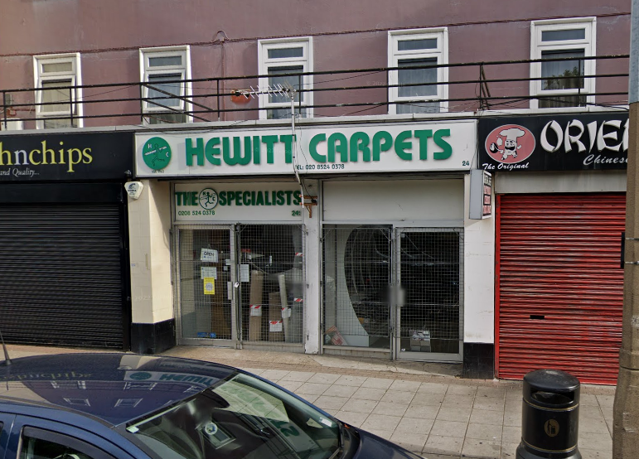

TO LET | LOCK-UP SHOP
 | 24 HATCH LANE
 | CHINGFORD E4 6LQ
LOCATION: | Access to the M11 and the North Circular Road.  British Rail nearby (Chingford Station). Close to bus stops with routes to Chingford, Walthamstow and Highams Park
DESCRIPTION: | Lock-up shop, reasonable condition with 2no. kitchen areas and 2no. WCs, rear access. Private yard with storage containers to rear and parking available. Available immediately. Currently split into 2 units (with access between the units) – dividing wall can be removed with appropriate professional advice.
FLOOR AREA: | Net internal area approximately 802sqft (75 sqm).
TERMS: | Minimum lease of 3 years  Planning Use Class E.  Catering (hot food) subject to planning requirements
RENT: | Offers in the region of £15,000 pa (exclusive)
RATES: | 01 April 2023: Rateable Value £13,250  Subject to small business rates relief – please make own enquiries with Council Business Rates Team
COSTS: | All legal costs will be borne by the new tenant (Costs TBC)
VIEWING: | By prior appointment with Property Services (Sunil Kumar)
 | Telephone 020 8496 8069 / 07989 195 279 or email: sunil.kumar@walthamforest.gov.uk
OFFERS: | To Sunil Kumar, Area Estate Manager.
 | Include:
- Details of your proposed use and length of lease required.
- Proof of identity i.e. a copy of passport / driving licence and a recent utility invoice for home address (no more than 3 months old)
- Last six months bank statements, together with mortgagees or landlords reference, two trade referees if applicable. 2-3 years trading accounts.
These particulars do not form part of any offer or contract. All statements contained in these particulars are made without responsibility of the vendor/agent/lessor and should not be relied upon as statements or representations of fact. Any intending purchasers/tenants must satisfy themselves by inspection or otherwise as to the correctness of each of the statements contained in these particulars. The vendor/agent/lessor does not give any warranty whatsoever in relation to the property.

