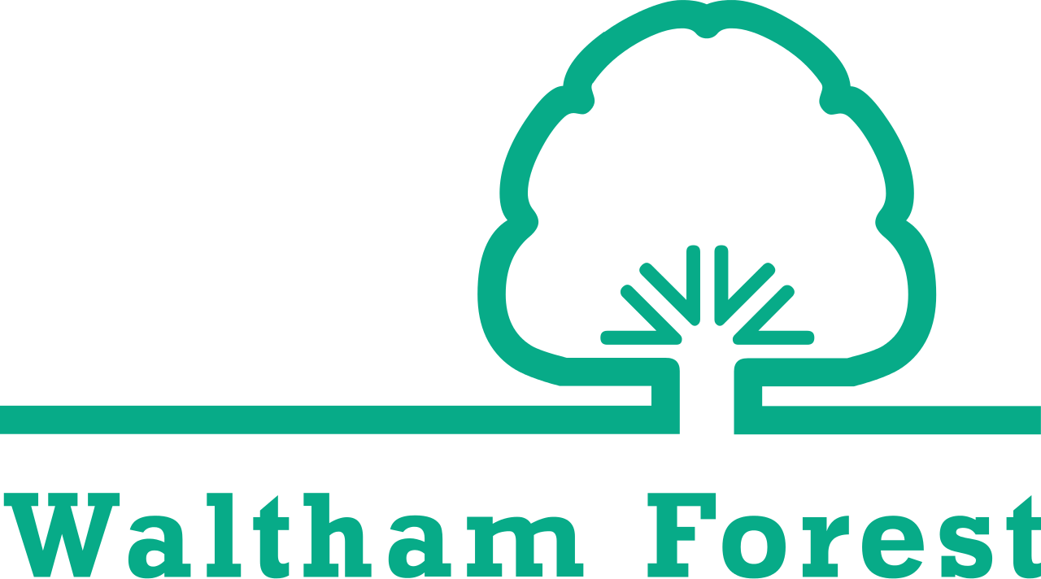
  - community walking and cycling fund 2024
  - application form

About your organisation
1.1 | Full name of applicant
1.2 | Name of organisation/group you represent
1.3 | Full postal address of the organisation (including postcode)
1.4 | Telephone number
1.5 | Email address
1.6a | Full name of the project manager  (if different from the applicant)
1.6b | Telephone number of the project manager  (if different from the applicant)
1.6c | Email address of the project manager  (if different from the applicant)
1.7 | Where did you find out about the Community Walking and Cycling Fund?
1.8 | What is the nature of your organisation? | A community group  A charitable/third sector organisation  Not for profit organisation, Community Interest Company (CIC) or social enterprise  Other (please specify)
1.9 | Has your organisation received any other funding from Waltham Forest Council in the last 3 years? | Yes  No
1.9a | If yes, please specify  - the funding source  - amount received  - details of the project that was funded  - LBWF service area and contact name
2.0 | Has your organisation received any other funding in the last 3 years? | Yes  No
2.0a | If yes, please specify  - the funding source  - amount received  - details of the project that was funded

About your project
2.1 | What is the name of the project that you are applying to the Community Walking and Cycling Fund for?
2.2 | Address of where the project will be delivered
2.3 | How much are you applying to the Community Walking and Cycling Fund for (up to £2500)?
2.4 | Description of project (max. 250 words)
2.5 | Describe the key aims of your project (what do you hope to achieve?) (max. 150 words)
2.6 | Describe why your project is unique to your organisation (max. 150 words)
2.7 | What are the existing skills and resources possessed by the organisation that will enable you to deliver your project? (max. 150 words)

About your project outcomes
3.1 | Which beneficiaries does your project aim to engage with, and how are you planning to reach and engage with them? (max. 150 words)
3.2 | What barriers to walking and/or cycling (as a means of transport, health and wellbeing or leisure) exist for your target group(s) that your project aims to address?  (max. 150 words)
3.3 | What is your expected number of beneficiaries and how did you calculate this? (max. 50 words)

Project management
4.1 | Please provide a simple project plan, including a project timeline and cost breakdown for project delivery, as an attachment.
4.2 | How will you ensure that the activities of your project are delivered and the beneficiaries are reached on time? (max. 150 words)
4.3 | How will you monitor and provide evidence of your project outcomes? (max. 150 words)
4.4 | How will your project continue to run and be sustained after you have spent the funding? (max. 150 words)
4.5 | Successful recipients of the Community Walking and Cycling Fund are expected to hold their projects between 01 April 2024 and 31 October 2024. Do you agree to this? | Yes / No
4.6 | Successful recipients of the Community Walking and Cycling Fund are required to submit a project update at two intervals when requested by a Council Officer. Do you agree to collect data, photos and testimonials (with written permission from participants) and provide this to the Council in a timely manner? | Yes / No  Signed:  Date:

The deadline to submit your application form and any supplementary information is 10 March 2024 at 23.59pm.

Please send your application form to:
Email: CWCF@walthamforest.gov.uk
Post: CW&CF - Sustainable Transport Team, London Borough Waltham Forest, Low Hall Depot, Argall Avenue, Leyton, E10 7AS (if posting please ensure it will be received by the deadline)

