North East London (NEL) Keyworking Service
For children and young people with autism and/or learning disability on the Dynamic Support Register.
What is a dynamic support register?

A dynamic support register is a list of people with learning disabilities and autism who need support because they at risk of going into hospital if they do not get the right care and treatment in the community. No one is added to the register without their consent.
Who do Keyworkers support?
The North East London Keyworking Service works with children and young people with learning disabilities and or autism, aged 0-25 years old who have complex needs and are on the local Dynamic Support Register.

North East London NHS Foundation Trust (NELFT) will be delivering this service throughout the boroughs of:
- Barking & Dagenham
- Havering
- Waltham Forest
- Redbridge
- City & Hackney
- Newham
- Tower Hamlets
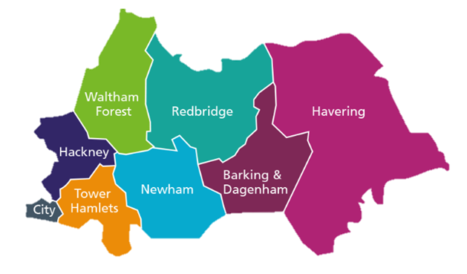

What do we do?
The aim of the Keyworking Service is to ensure children, young people and their families’ voices are heard and represented and they have the right support from services at the right time. The aim is to support a reduction in admission to hospital or reduce lengths of stay in specialist hospitals as well as helping to improve experiences and outcomes.

How will we provide support?
The keyworking service will tailor the support it provides based on each child, young person and family’s needs.
They will work with the services already involved in the child’s care and treatment to identify where additional support is most required, to make sure that their involvement is adding value and not duplicating or disrupting existing support.
We will not replace any health and social care workers currently supporting families.
Sometimes the keyworking case managers may work directly with the child, young person and family, or they may work with services (social care, education, health etc) to join up care and treatment and meet any gaps.
Examples of what we may do to help avoid admission or support discharges include:
- Advocate for families', carers and children and young people, to ensure voices are heard, understood, and respected
- Ensure service users have the right support from services within a timely manner at the right time
- Supporting services and working in a joined-up way
- Representing service users when they may not feel confident or able to speak up themselves
- Providing information and guidance in a way that will help improve the quality of life for service users
- Helping service users work with and have access to health, care, education and voluntary organisations
- Helping with the transition into adulthood and adult services
- Attending and following up on actions or recommendations from any review meetings

How to access the keyworking service:
To access keyworking support, children and young people must be on their local dynamic support register. Families can ask a professional working with them to refer, or you can make a self-referral by contacting the dynamic support register holders.

