**Property and Major Projects**

Director: Aiden McManus

Waltham Forest Town Hall Complex, Forest Road, Walthamstow, E17 4JF

**TO** **LET** **Industrial Unit**

**UNIT 3, ACACIA BUSINESS CENTRE,** **LEYTONSTONE,** **LONDON** **E11** **3PJ**

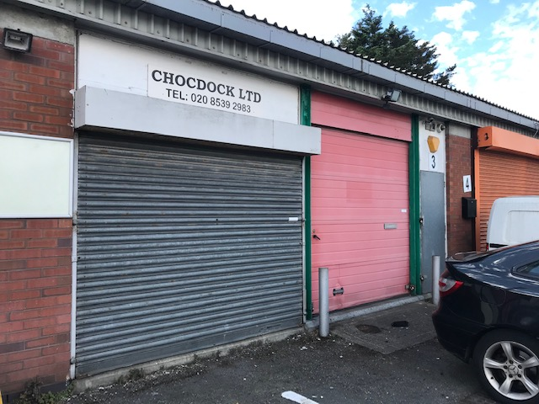

**DESCRIPTION:** 1980’s purpose built, light industrial, ground floor unit with exclusive communal parking and CCTV. Benefits from office room, store, kitchenette, and WC.

**FLOOR** **AREA:** Gross Internal Area approximately 797sqft (74sqm)

**TERMS:** New lease 3 years+. Light industrial (Use Class E) / B8 uses excluding vehicle repairs, foods or similar uses. Security of tenure, Landlord & Tenant Act 1954 protection

**RENT: Offers in the region of £12,000 pa exclusive (vat not applicable)**

**RATES:** From 01 April 2023 RV = £10,500.

Small Business Rates Relief – rates not payable on a property with a rateable value of £12,000 or less. Please contact Business Rates Department to confirm.

**COSTS:** Services Charges (approx.): £500+vat pa

Building Insurance: £800pa (vat N/A)

Management charge: £250+vat pa

(these costs are approximate and subject to change)

LBWF legal and surveying fees payable for new lease. Superior landlord legal fees payable also.

**VIEWING /**

**ENQUIRIES:** Estate Management Surveyor, Sunil Kumar. Telephone 020 8496 8069

Or email: [sunil.kumar@walthamforest.gov.uk](mailto:sunil.kumar@walthamforest.gov.uk)

These particulars do not form part of any offer or contract. All statements contained in these particulars are made without responsibility of the vendor/agent/lessor and should not be relied upon as statements or representations of fact. Any intending purchasers/tenants must satisfy themselves by inspection or otherwise as to the correctness of each of the statements contained in these particulars. The vendor/agent/lessor does not give any warranty whatsoever in relation to the property

