Property and Asset Management

Waltham Forest Town Hall, Forest Road, London E17 4JF

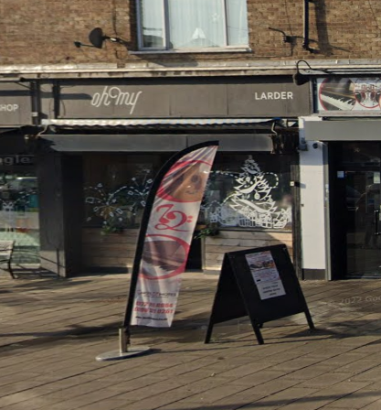

TO LET | LOCK-UP SHOP
 | 94 OLD CHURCH ROAD
 | CHINGFORD E4 8BX
LOCATION: | Access to the M11 and the North Circular Road.  British Rail nearby (Chingford Station).
DESCRIPTION: | Lock-up shop, very good condition with store / kitchen room and WC, rear access. Available mid-late Sep 2022
FLOOR AREA: | Net internal area approximately 732 sq ft (68 sqm)
TERMS: | Minimum lease of 3 years for Planning Use Class E.  Catering (hot food) subject to planning requirements
RENT: | Offers in the region of £15,000 pa (exclusive)
RATES: | 01 April 2020 – present: Rateable Value: £9,003 (approx. – to be confirmed by VOA).  Subject to small business rates relief – please make own enquiries
COSTS: | All legal costs will be borne by the new tenant (£1,500 plus VAT)
VIEWING: | By prior appointment with Property Services (Sunil Kumar)
 | Telephone 020 8496 8069 / 07989 195 279 or email: sunil.kumar@walthamforest.gov.uk
OFFERS: | To Sunil Kumar, Area Estate Manager.
 | Include:
- Details of your proposed use and length of lease required.
- Proof of identity i.e. a copy of passport / driving licence and a recent utility invoice for home address (no more than 3 months old)
- Last six months bank statements, together with mortgagees or landlords reference, two trade referees if applicable.
These particulars do not form part of any offer or contract. All statements contained in these particulars are made without responsibility of the vendor/agent/lessor and should not be relied upon as statements or representations of fact. Any intending purchasers/tenants must satisfy themselves by inspection or otherwise as to the correctness of each of the statements contained in these particulars. The vendor/agent/lessor does not give any warranty whatsoever in relation to the property.

