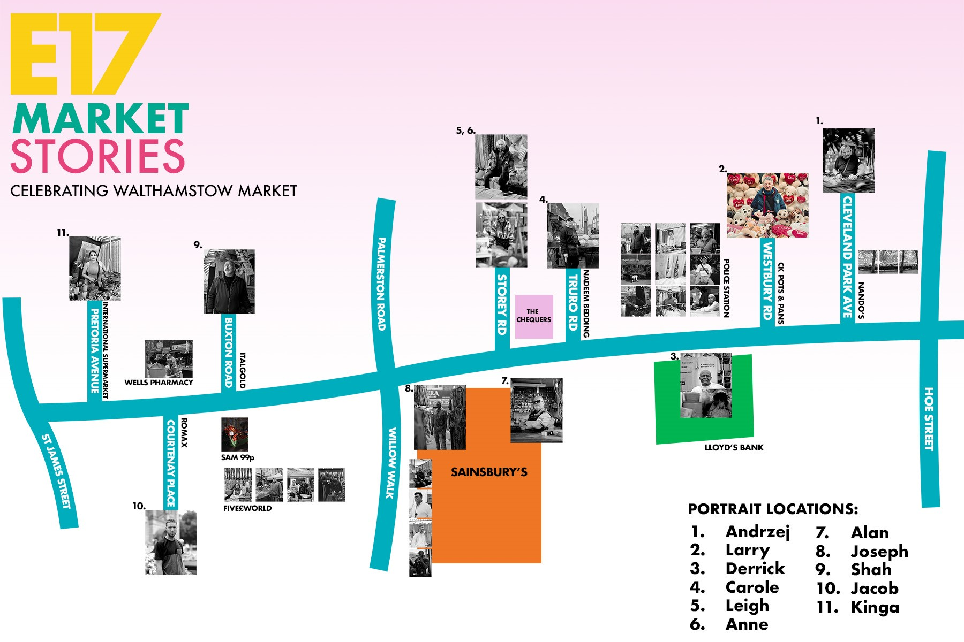

Locations of portraits with accompanying videos:
- Andrzej’s portrait is located at Nando’s, 261 High Street, 1 The Scene, E17 7FD. The video QR link is located under the Nando’s sign on Cleveland Road or unnumbered lamppost outside Jennings Bet, 208 High Street, E17 7JH
- Larry’s portrait is located at CK Pots & Pans, 219 High Street, E17 7BH. The video QR link is located on lamppost number 13 on the High Street.
- Derrick’s portrait is located at Lloyds Bank, 180-182 High Street, E17 7BX. The video QR link is on lamppost number 16 on the High Street.
- Carole’s portrait is located at Nadeem Bedding, 157 High Street, E17 7BX. The video QR link is on lamppost number 41 and 42 on the High Street.
- Leigh’s portrait is located at Paddy Power, 145a High Street, E17 7BX. The video QR link is on lamppost number 47 and 48 on the High Street.
- Anne’s portrait is located at The Chequers, 145 High Street, E17 7BX. The video QR link is on lamppost number 49 on the High Street.
- Alan’s portrait is located at Femme Connection, 112b High Street, E17 7JY. The video QR link is on lamppost number 57 on the High Street.
- Joseph’s portrait is located at Sainsbury’s, 112 High Street, E17 7JY. The video QR link is on lamppost number 58 and 59 on the High Street.
- Shah’s portrait is located at Italgold Jewellery, 65b High Street, E17 7AD. The video QR link is on lamppost number 88 and 89 on the High Street.
- Jacob’s portrait is located at Romax, 34 High Street, E17 7LD. The video QR link is on lamppost number 95 on the High Street.
- Kinga’s portrait is located at International Supermarket, 7-17 High Street, E17 7AB. The video QR link is on lamppost number 101.
Further portraits and scenery photography (without video links) can also be found in the following places.
- Poundland, 259 High Street, E17 7BH, on the Cleveland Road side of the building.
- Metropolitan Police Sub-station, 191-193 High Street, E17 7BX.
- Sainsbury’s, 112 High Street, E17 7JY on the Willow Walk side of the building.
- Sam 99p Store, 60 High Street, E17 7LD.
- Five£World, 52 High Street, E17 7LD.

