**Learning Disability Week Event Image Guide**

Monday 20th June 2022

**How to find Fellowship Square**

The address is:

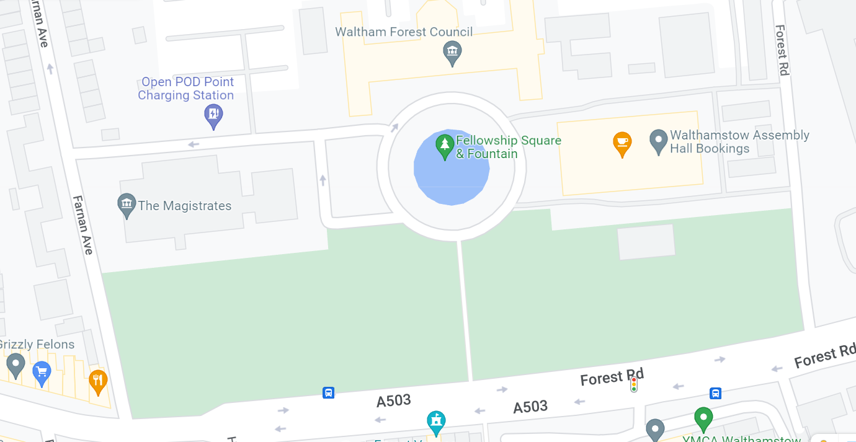Waltham Forest Town Hall, Forest Rd, London E17 4JF

If you are arriving by car and parking at Fellowship Square, please use the car park entrance on Farnan Ave.

There are 13 disabled bays. If you have a blue badge you can park in any bay in the car park for free.

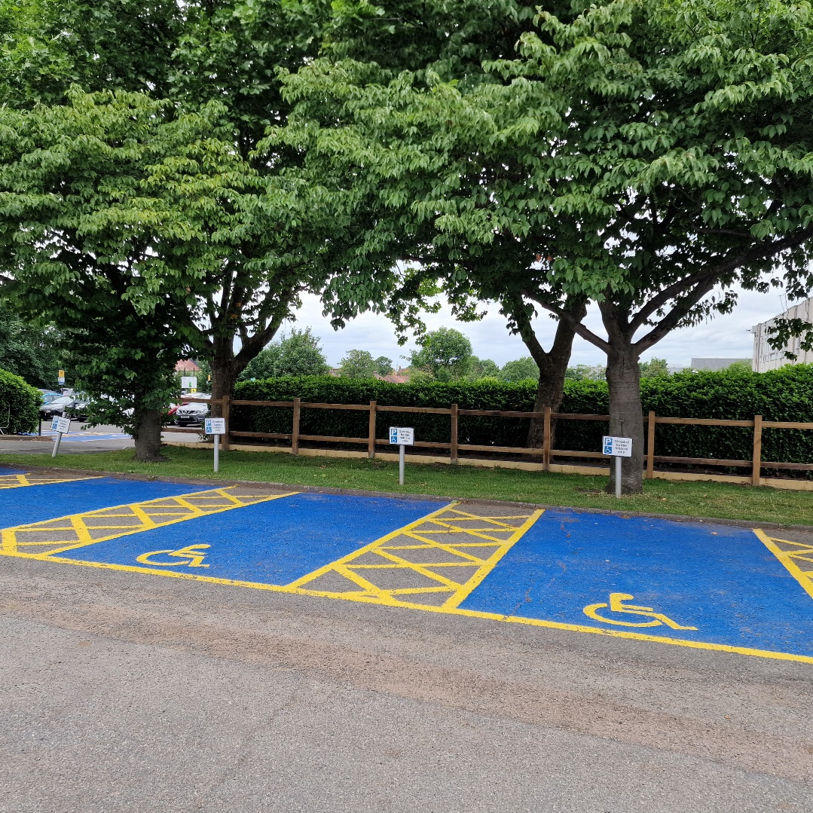

If you are arriving at Fellowship Square by any other transport, please use the main entrances on Forest Road.

**In Fellowship Square**

There will be information stalls and activities in Fellowship Square.

There is also a fountain with lights.

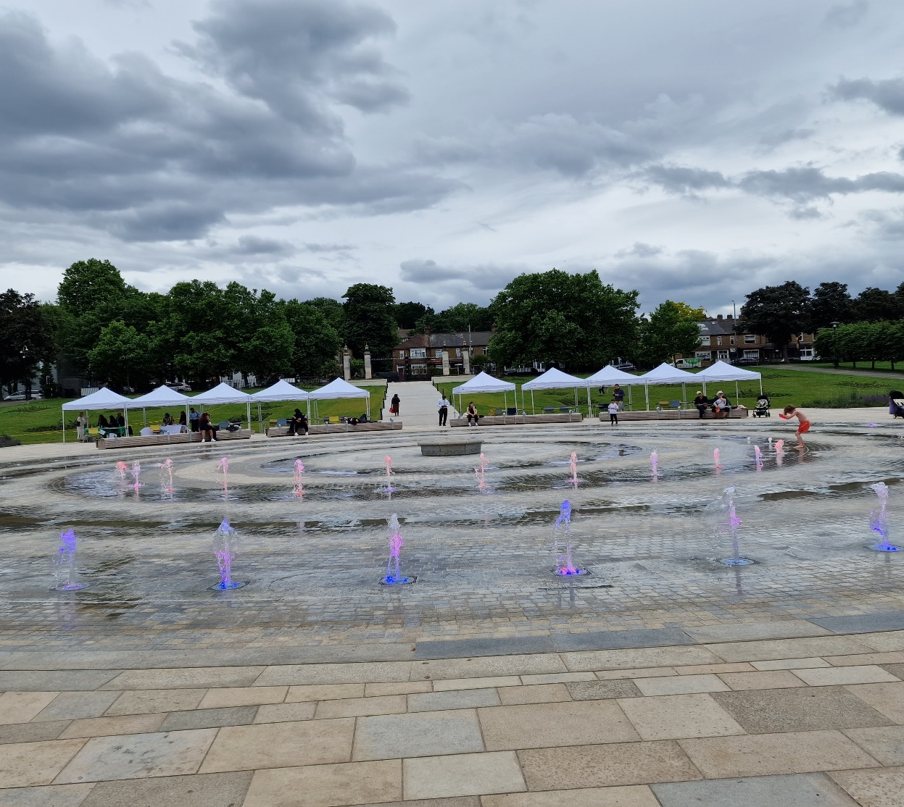

**Facilities**

**Toilets**

Toilets are located in the Assembly Hall.

There is an accessible toilet to the left of the building entrance.

There are more toilets in the Assembly Hall downstairs.

Enter through the main entrance, turn **left** and go downstairs for **male** toilets.

Enter through the main entrance, turn **right** and go downstairs for **female** toilets.

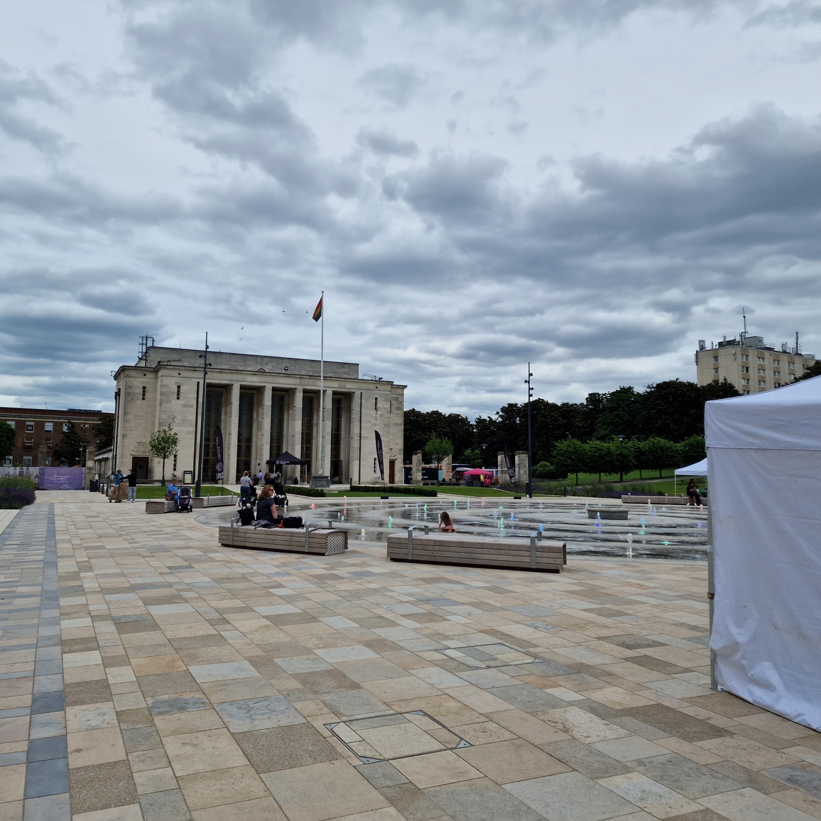

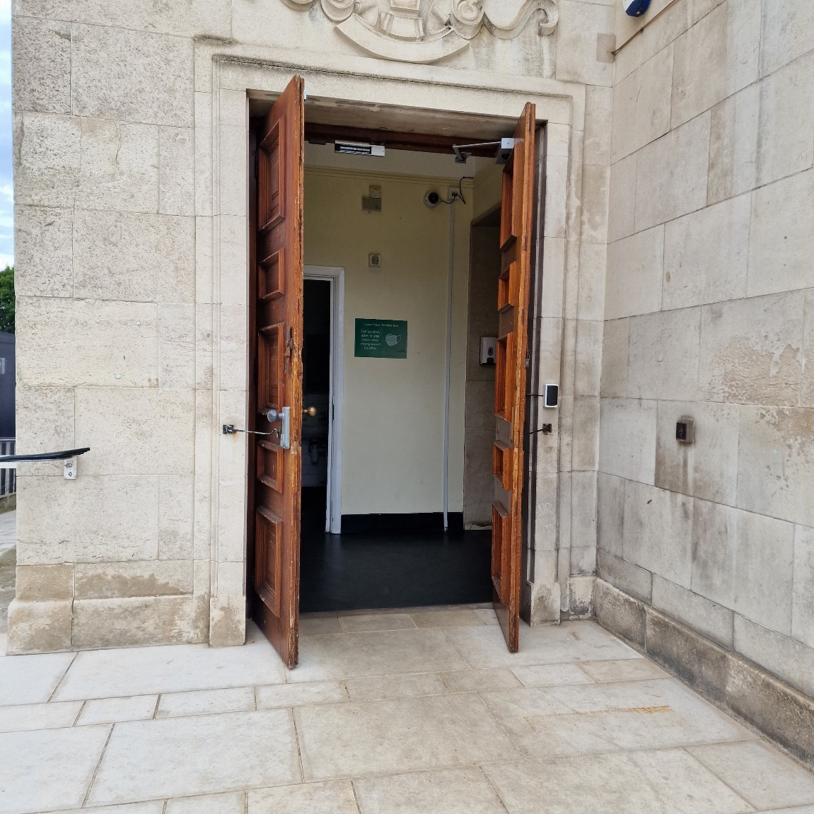

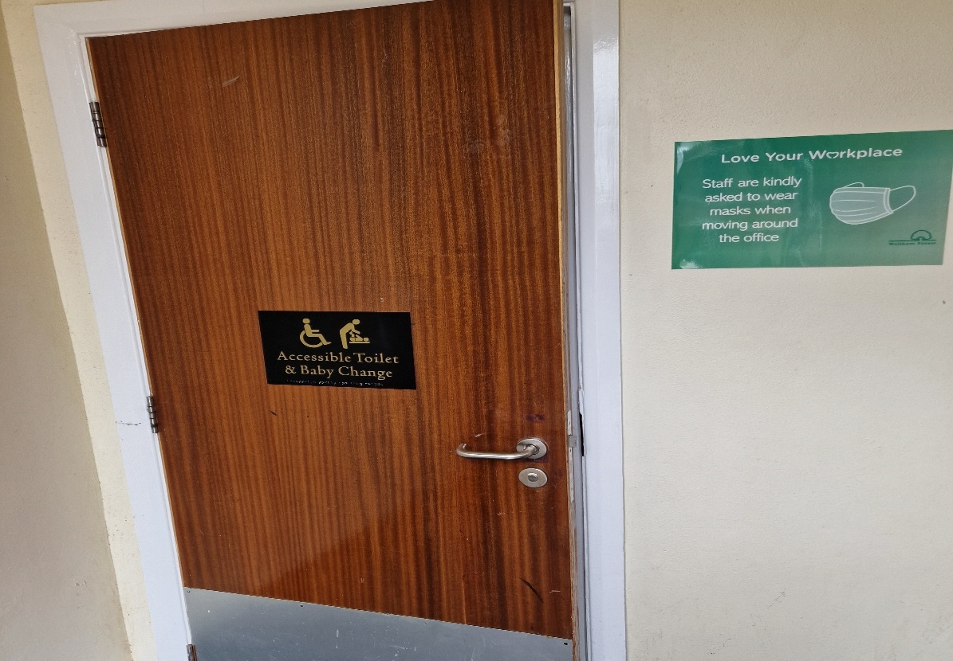

There will also be a Mobiloo Changing Places Facility. This is portable and will be located near the disabled bays car park. It has a hoist and changing table.

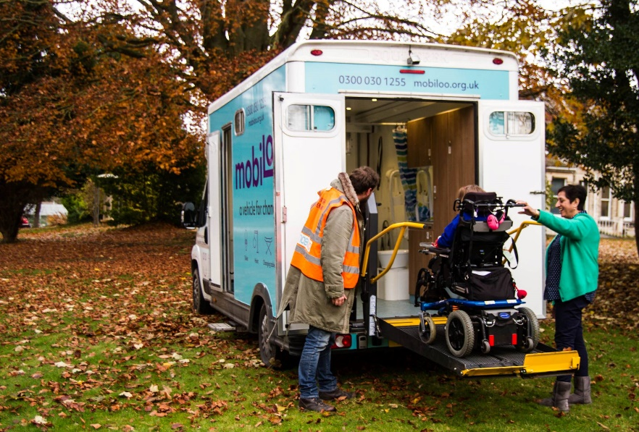

**Food and drink**

Stow Grab n Go will have a food stall with snacks and drinks if you would like to buy them.

You can find them at a stall with this logo:



In the Assembly Hall, there is also café.

Enter through the main entrance and you arrive at the café.

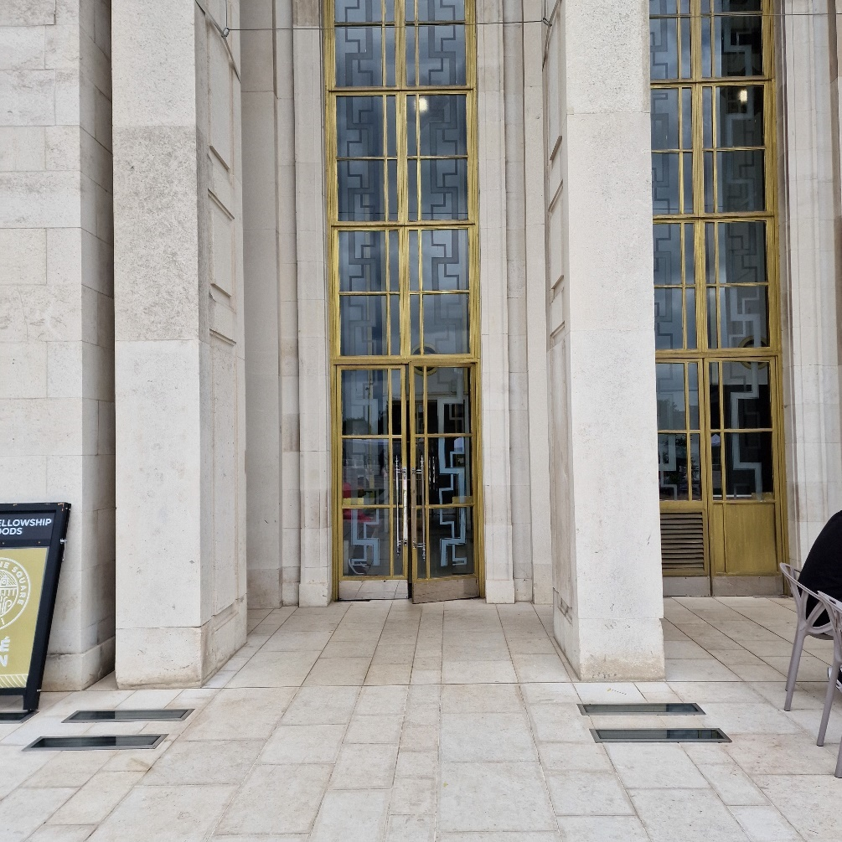

**Quiet room**

The quiet room is located at the back of the Assembly Hall.

Please go around the Assembly Hall on either side then you will arrive at the back doors.

There will be signage to direct you to the Quiet Room.

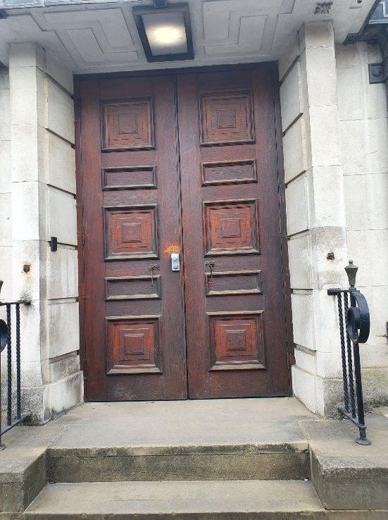

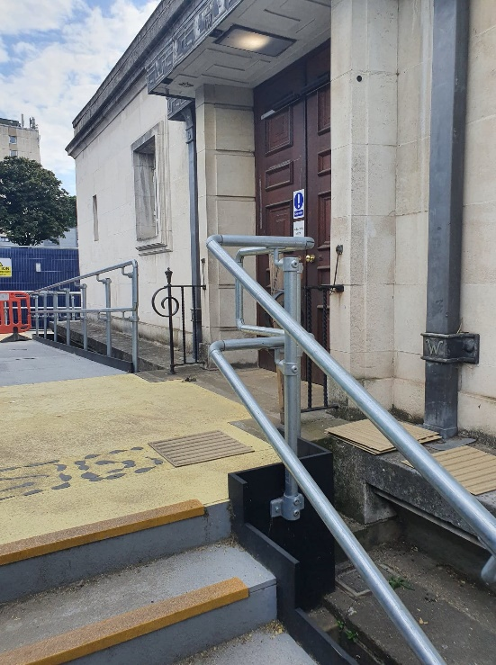

You can enter through either of these doors which will be open.

Go straight, through another set of doors, then you will arrive in the corridor.

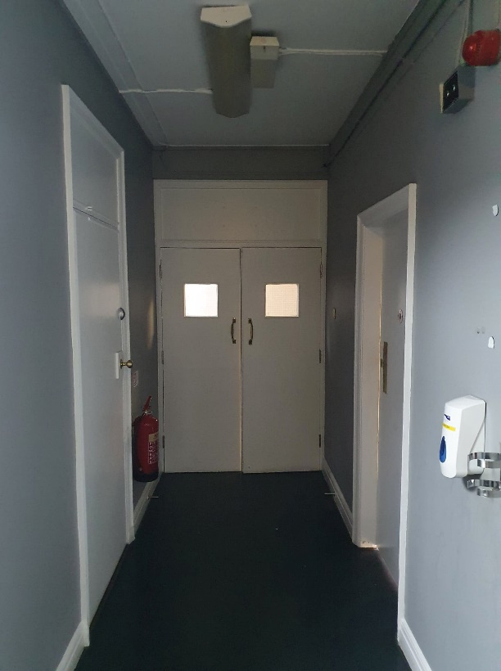

The quiet room is in the middle of this corridor. There will be signage with directions.

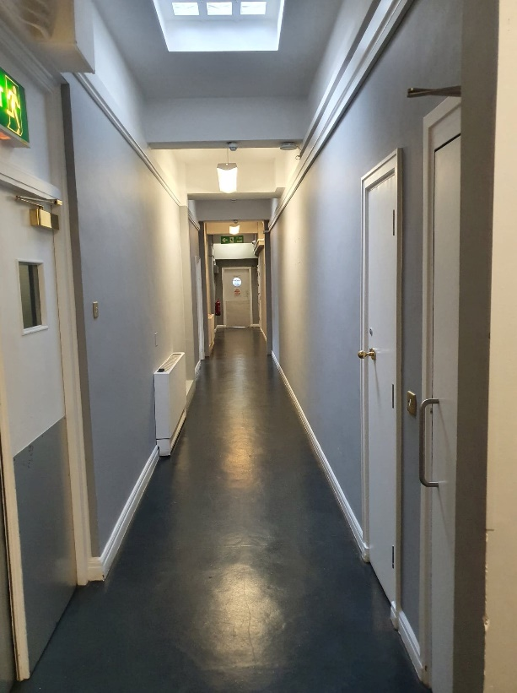

This is the quiet room:

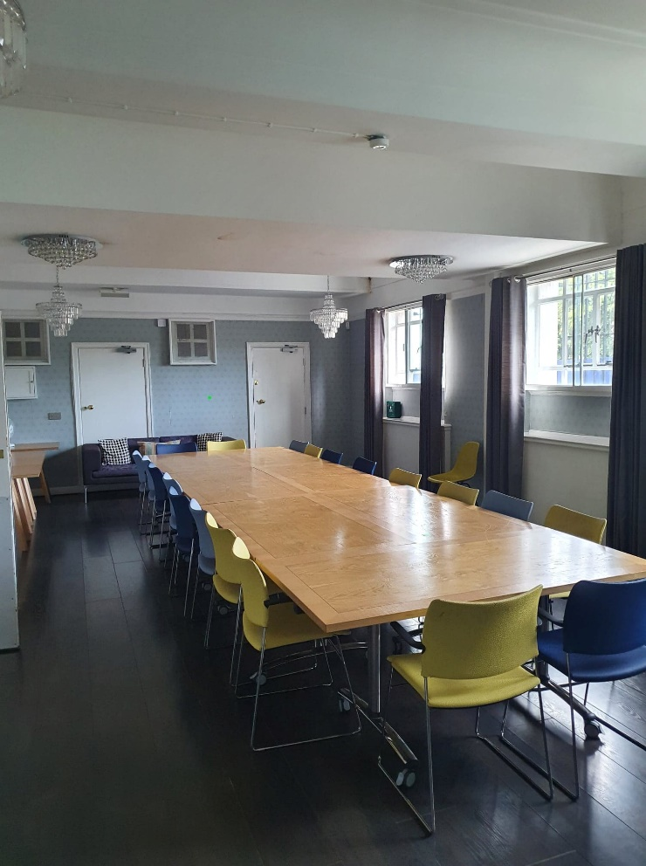

There will not be a table in the centre of the room for the event. The chairs will be moved to the sides of the room.

**Information and Guidance**

There will be staff members in Fellowship Square to help with information and directions.

Staff will wear lanyards like this:

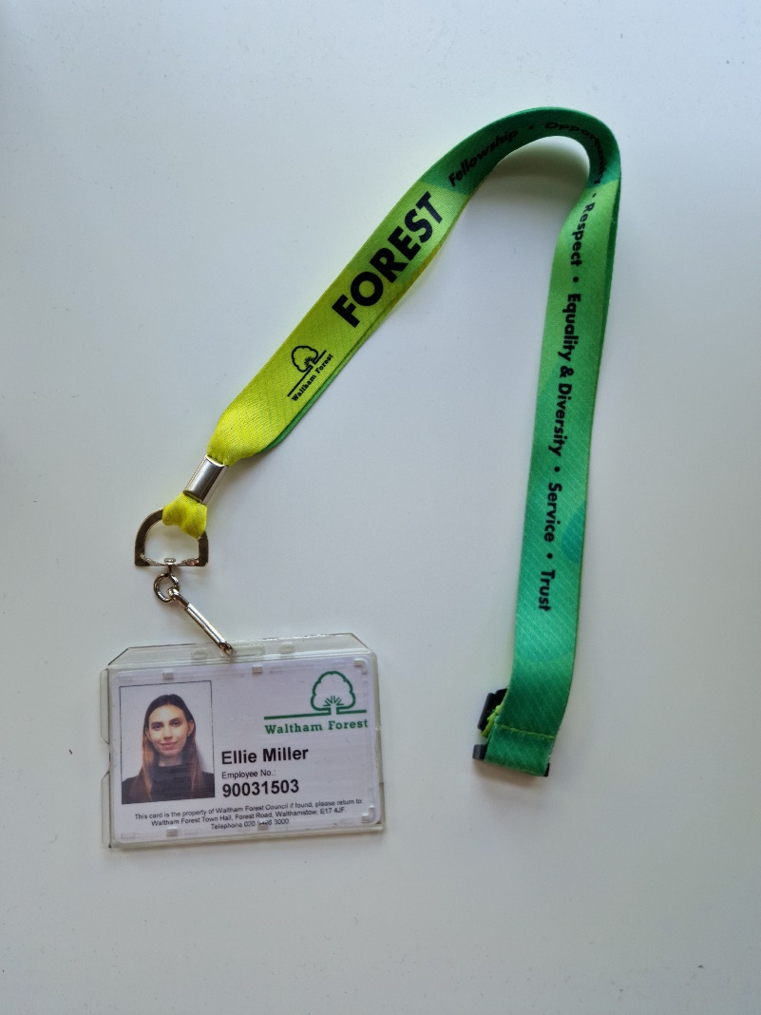

Ellie Miller will be the lead staff member on the day.



There will also be signs with directions or a printed copy of this guide at the information stalls if you do not wish to speak to staff.