Chingford Mount Cemetery

Pricing – Index

1. Traditional Burial
2. Lawn Burial
3. Cremated remains plot
4. Memorial Bench
5. Search fees
6. Miscellaneous

**Fees & Charges from 1st April 2022**

Chingford Mount Cemetery

Traditional Burial

Headstone and full kerbing. Can fit two coffins and up to six sets of ashes.

[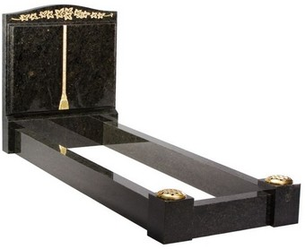](http://www.google.co.uk/url?sa=i&rct=j&q=&esrc=s&source=images&cd=&cad=rja&uact=8&ved=0ahUKEwio7vCQianSAhUCbRQKHVU5C7gQjRwIBw&url=http://www.headstonesofdistinction.co.uk/traditional-memorials-with-surrounds-14.asp&bvm=bv.148073327,bs.2,d.ZGg&psig=AFQjCNGNfMJEAfOZ5PRPj-KLVkhNquMHUA&ust=1488037306174541)

These plots are located next to one of our roadways and include a landing foundation which is ready to accept a traditional marble memorial and surround (example above) to be fitted by your stonemason.

**Exclusive right of burial** (50-year term) **£2310**

**Interment Fee (one person)**  **£1650**

**Landing foundation**  **£685**

**Prime position fee £350**

**TOTAL (one person) = £4995**

Extension of Burial Rights for a further 10 years is £355

(Full Length Traditional Memorial Permit Fee of £295 payable when installed).

Chingford Mount Cemetery

Lawn Burial

Headstone 18” kerbing. Can fit two coffins and four sets of ashes.

[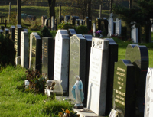](http://www.google.co.uk/url?sa=i&rct=j&q=&esrc=s&source=images&cd=&cad=rja&uact=8&ved=0ahUKEwju7pGGmszSAhUIrRoKHW9NCzQQjRwIBw&url=http://www.merton.gov.uk/community-living/bdmcp/cemeteries/mertoncemeteries/mertonandsuttoncemetery.htm&bvm=bv.149093890,d.ZGg&psig=AFQjCNGfi1A2BhR6ZcTJEHV_Ha_zGI1odA&ust=1489244277430196)

These plots include a headstone foundation which is ready to accept a traditional marble memorial (examples above) to be fitted by your stonemason.

**Exclusive right of burial** (50-year term) **£1730**

**Interment Fee (one person)**  **£1400**

**Headstone foundation**  **£200**

**TOTAL (one person) = £3330**

Extension of Burial Rights for a further 10 years is £355

(Lawn Headstone Memorial Permit Fee of £205 payable when installed).

Chingford Mount Cemetery

Cremated Remains Plot

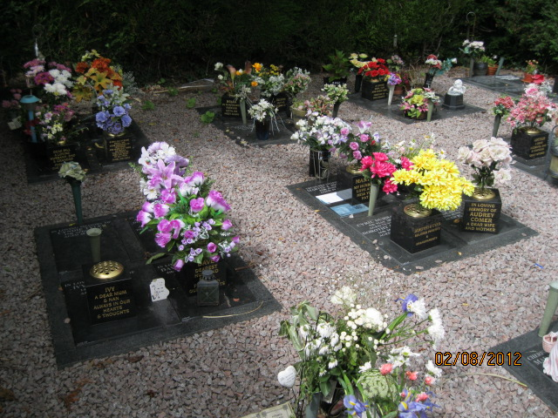

These plots are located in the Remembrance Garden, allows for the interment of two sets of ashes. A granite tablet and inscription are included.

**Exclusive right of burial** (25-year term) **£1210**

**Interment Fee (one person)**  **£360**

**Interment fee (two persons)**  **£720**

**Granite memorial tablet with first inscription £610**

**Second inscription on granite memorial tablet £265**

**TOTAL (one person) = £2180 TOTAL (two persons) = £2805**

**n.b. CRGA plots are strictly for the pouring of ashes only. Caskets, containers and other items are not permitted.**

Extension of Burial Rights for a further 10 years is £355

Chingford Mount Cemetery

Half Grave for Cremated Remains Burial

Headstone. NO KERB PERMITTED. Can accept up to 8 sets of ashes.

[](http://www.google.co.uk/url?sa=i&rct=j&q=&esrc=s&source=images&cd=&cad=rja&uact=8&ved=0ahUKEwju7pGGmszSAhUIrRoKHW9NCzQQjRwIBw&url=http://www.merton.gov.uk/community-living/bdmcp/cemeteries/mertoncemeteries/mertonandsuttoncemetery.htm&bvm=bv.149093890,d.ZGg&psig=AFQjCNGfi1A2BhR6ZcTJEHV_Ha_zGI1odA&ust=1489244277430196)

These plots include a headstone foundation which is ready to accept a traditional marble memorial headstone (examples above) to be fitted by your stonemason.

**Exclusive right of burial** (50-year term) **£1730**

**Interment Fee (one person)**  **£360**

**Headstone foundation**  **£200**

**TOTAL (one person) = £2290**

Extension of Burial Rights for a further 10 years is £355

(Lawn Headstone Memorial Permit Fee of £205 payable when installed).

Chingford Mount Cemetery

Memorial Bench

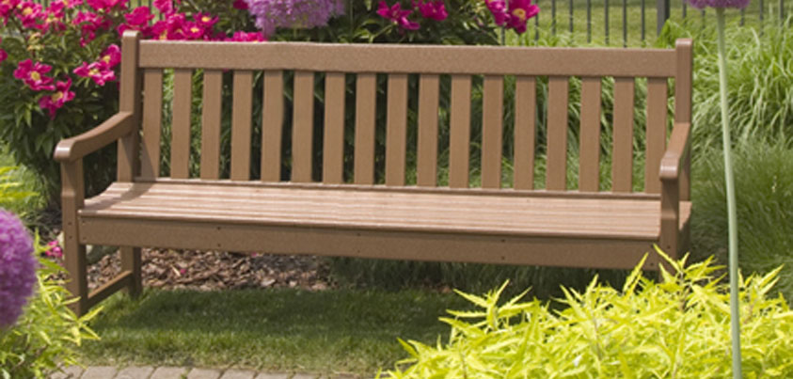

**Polywood Bench 4’ (2-seater) -** Price excludes dedication lettering **£660.00**

**Bench Permit of 20 years** for any bench installed in the Cemetery **£375.00**   **Base for Bench £90.00**

**TOTAL £1125.00**

Traditional Teak colour - Height x Width x Depth 35” x 48” x 24”



**Carved dedication per letter £6.00**

(Dedication wording must be 100% correct at time of ordering as mistakes cannot be rectified after carving is complete).

Only authorised benches with permit will be allowed in the Cemetery.

* Please note that delivery can be up to 12 weeks

Chingford Mount Cemetery

Search Fees

Grave Search Charges

|  |  |  |
| --- | --- | --- |
| £18.00 | Where a search is conducted via the cemetery office computerised records from 1978 onwards | Per name |
| £26.00 | Where the exact date of death is known pre 1978 | Per name |
| £52.00 | Where the date of death is within a given period of time | Per name / per 5-year search period |
| **ADDITIONAL CHARGES WILL APPLY FOR:** | | |
| £23.00 | For the provision of a photocopy of the burial record and a map showing the position of the grave within the boundaries of the Cemetery | |
| £36.00 | For the provision of two photographs (per Grave) inclusive of postage or email | |
| £27.00 | Accompanied visit to graveside (pre-booked) | |

A grave search request form must be completed by the applicant and sent with the correct payment to Chingford Mount Cemetery Office. We will endeavour to provide responses to family history searches within 28 working days of receipt of the request. Searches connected to a request for a burial will be prioritised and processed much more quickly.

Chingford Mount Cemetery

Miscellaneous

|  |  |  |
| --- | --- | --- |
| **Removal & Replacement of Memorials (for burials)** |  |  |
| Removal & replacement of headstone only [up to 3 ft] |  | £150.00 |
| Removal & replacement of traditional memorial |  | £295.00 |
| Removal & Replacement of lawn kerb |  | £95.00 |
| Removal & Replacement of larger memorials | Price on application | |
| Re-opening of vault | Price on application | |
|  |  |  |
| **Erection of Memorials – {Not to exceed 3ft in height}** |  |  |
| Headstone foundation |  | £200.00 |
| Lawn headstone permit with one inscription only |  | £205.00 |
| Additional inscription permit |  | £115.00 |
| Wooden Cross permit when used as a Permanent Memorial * |  | £215.00 |
| Kerb-set permit |  | £110.00 |
| Additional plate/plaque/book permit |  | £110.00 |
| Vase permit |  | £110.00 |
| Traditional memorial permit fee |  | £295.00 |
| **Levelling Memorials** |  |  |
| Headstone & foundation |  | £135.00 |
| Kerb set |  | £80.00 |
|  |  |  |
| **Certificates** |  |  |
| Certificate of Exclusive Right of Burial |  | £90.00 |
| Transfer of Exclusive Right of Burial |  | £80.00 |