Pavement Licence Site Notice

[ClauseS 2] of the Business and Planning Act 2020.

I Natalie Stopford,

do hereby give notice that on 13 April 2021 I have applied to Waltham Forest Council for a ‘Pavement Licence’ at: 169 Francis Road, London, E10 6NT

Known as: Marmelo

The application is for:
An outdoor seating to the front of the premises for serving of food and drink

Any person wishing to make representations to this application may do so by writing, preferably by email, to:

street.trading@walthamforest.gov.uk

postal address:
Street Trading Central library 206 High Street Walthamstow, London
E17 7JN

(Please note that hand written representations will not be considered if they are not received within five working days)

by: 20 April 2021

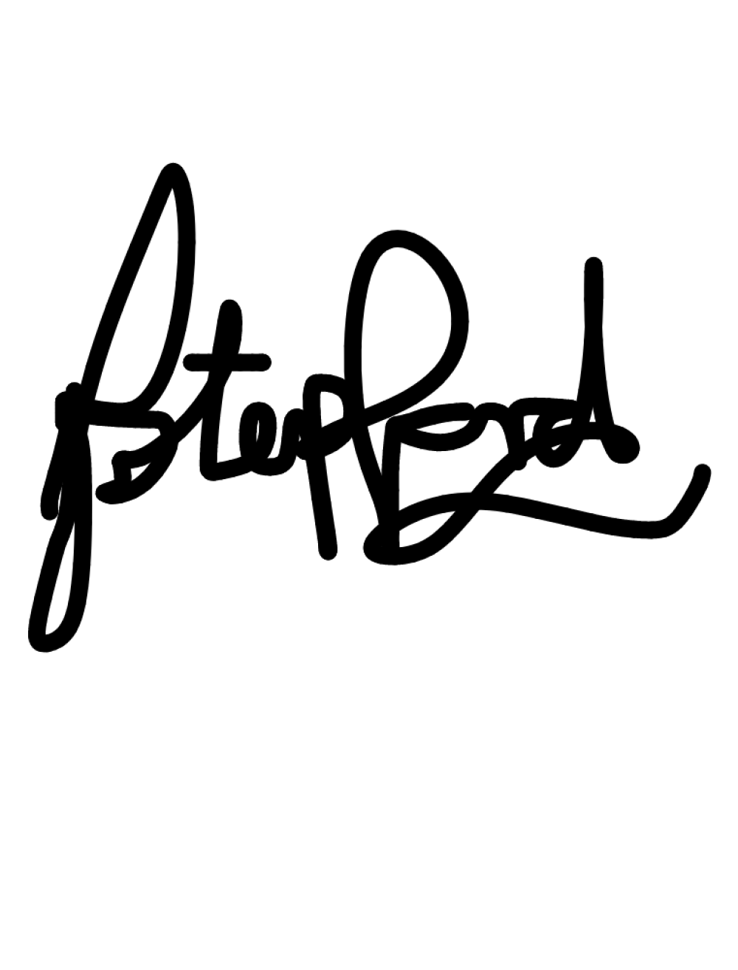
The application and information submitted with it can be viewed on the Council’s website.

Signed ......................................................................

Dated 13April 2021

