Safety warning issued for plastic Coca-Cola bottles
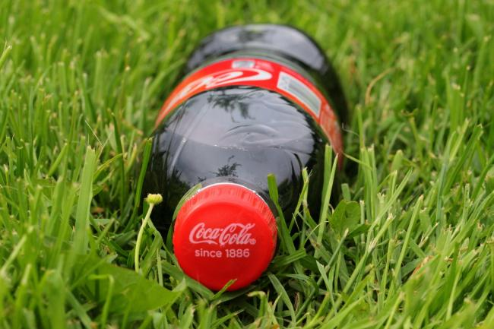
Some bottles are damaged and could pose a safety risk (Photo: Pxhere)

Supermarkets are issuing an urgent recall for Coca-Cola bottles as certain batches could pose a safety risk.
Coca-Cola European Partners have issued a warning after certain ‘Original Taste’ 1.5 litre bottles have damaged neck rings with a sharp rim edge.
The bottles could pose a safety risk due to the sharp edge, and Coca-Cola has issued advice on how to best open it and avoid injury.
The bottles affected have the best before date of 30 September 2020, with the following batch codes:
• 083EK3TT:TT
• 084EK3TT:TT
• 085EK3TT:TT
• 086EK3TT:TT
• 087EK3TT:TT
• 088EK3TT:TT
• 089EK3TT:TT
• 090EK3TT:TT
Shoppers are being urged to follow certain safety measures when opening the bottle.
The Food Standards Agency (FSA) website said: "Coca-Cola European Partners is issuing precautionary advice to consumers who have purchased the above product.
"As a precaution, you should examine the bottle neck ring carefully before opening.
"If you see damage to the bottle neck ring, open the bottle with care and ensure that your hand is placed on the cap and above the bottle neck when opening the bottle."
Product safety notices have been issued to supermarkets, and customers who bought the bottle are asked to read the advice by supermarkets before attempting to open it.
If it appears the bottle cannot be opened safely, then they are asked to return the unopened bottle to the store.

