Parents and Carers Guide to the
Characteristics of Effective Learning

In-order for children to learn best, research has shown that they need to develop and learn certain traits. These traits are known in the Early Years Foundation Stage Statutory Framework as the Characteristics of Effective Learning.

What are the Characteristics of Effective Learning?
The Characteristics of Effective learning are all about how children learn. They are broken down into three characteristics:

Playing and Exploring – Engagement
Finding out and exploring
Playing with what they know
Being willing to ‘have a go’
Active Learning – Motivation
Being involved and concentrating
Keeping trying
Enjoying and achieving what they set out to do
Creating and Thinking Critically – Thinking
Having their own ideas
Making links
Choosing ways to do things

Talk to your child about it being ok if you cannot achieve what you set out to do. Teach your child how to problem solve by asking them open questions. E.g. ‘What can you do now?’
Encourage your child to have a ‘can do’ attitude to new things, be positive with your child, giving specific praise and encouragement. Praise them for the effort involved, not just the end result.
Ways to Support Your Child’s Characteristics of Effective Learning

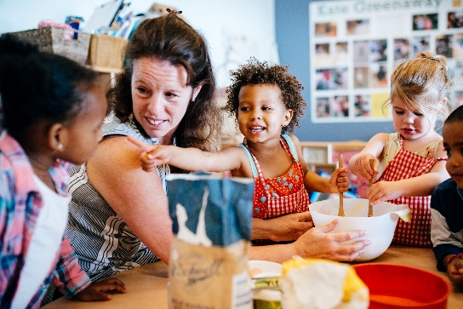
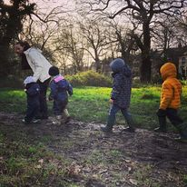

Be a role model and show your child you are interested in learning about things too. Learn together! Follow your child’s interests, if they enjoy something, encourage it further. This will develop their concentration skills.
At first set your child tasks that are simple, this will boost their confidence. Once they enjoy a challenge, set the aims higher and encourage them to take risks. Encourage your child to talk through what they are doing or making. Let them know it’s ok to change their plans and modify something.

