# Property and Asset Management

Director – Commercial Estate & Investment: Freddie Murray

Magistrates Building, Waltham Forest Town Hall Complex, 1A Farnan Avenue, Walthamstow, E17 4NX

**EXPRESSIONS OF INTEREST:**

**Commercial Units Central Parade/Eastfield Road, London E17 4RT**

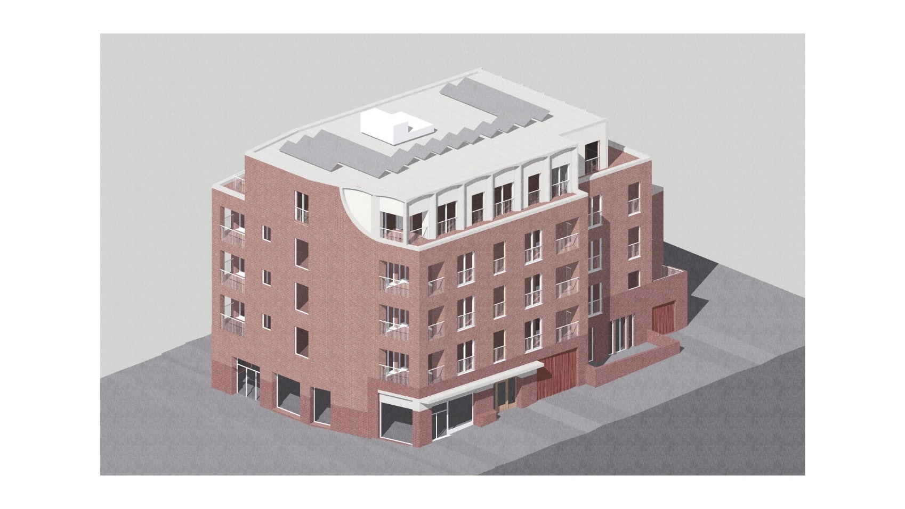

*Artist’s Impression of Eastfield Road Frontage*

1. **Description:**

Central Parade is a prominent residential block, situated in Walthamstow Town Centre on Hoe Street opposite The Scene. It consists of 35 council homes, along with several commercial units on the ground and upper floors. In October 2017, a Historic England Listing (Listing) placed on Central Parade, registered the building as a Grade II listed building of special architectural and historic interest.

The development will provide holistic regeneration, including new housing and commercial space, to complement the successful Central Parade retail units and CentrE17 community performance venue. The redevelopment of the service yard and garages at the rear of the site to delivering 19 new homes, 50% of which will be affordable, along with the conversion of commercial units within the existing building to deliver six new council homes. The scheme comprising 19 homes, 50% of which will be affordable, and 167m2 of new commercial space.

The Council is working with developer Thomas Sinden Limited Interiors as Design and Build contractors. The main refurbishment will begin immediately and is expected to complete in Summer 2022.

**What happens when?**

* Main redevelopment started in summer 2021
* Work is expected to finish in summer 2022

The development of the rear of the parade only and improvement to the existing building. It is close to ‘The Scene’ which comprises of five restaurants including Turtle Bay, Nando's, Five Guy’s and a Nine-screen Empire cinema and a brand-new Heavenly Dessert Restaurant.

The new commercial units are suitable for numerous uses including E (The Town and Country Planning (Use Classes) (Amendment) (England) Regulations 2020). The approved planning uses for the commercial accommodation are A1 (cafe), A3 (restaurant / café), A4 (bar / pub), B1a (office, but not bank, estate agent) and D1 class use.

The commercial space has been designed to achieve a BREEM rating of ‘very good’.

The council is seeking expressions of interest from innovative and unique businesses for this new exciting opportunity.

**FLOOR AREA:**

**Ground Floor 167 sq. m2 (1797.60 sq. ft.)**

**Terms: New Full Repairing INSURING LEASE, 10 years fixed term, outside the Landlord & Tenant Act 1954 Part II, secs 24-28.**

**Lease Break:** After five years, six months written notice exercisable by either Landlord or Tenant at any time.

**The Rent: Rental offer in excess of £40,00 per annum exclusive**

**Service Charge: £5,500 per annum**

**Business Rates: The rateable value (RV) £34,500. The rates payable April 2021 to March 2022: £17,595**

If you are interested in finding out more and are serious in expressing an interest, then please get in touch

directly with the Council and we are happy to discuss the project with you and potential terms on offer.

CONTACT DETAILS: Without prejudice and subject to contract, to the following address:

Property and Asset Management, London Borough of Waltham Forest | Magistrates Court | Town Hall

Complex | 1 Farnan Avenue| London E17 4JF.

**Email: tina.ogunremi@walthamforest.gov.uk**

**Mobile: 07435 998387**

**Floor Areas: Ground Floor (see layout plans at Appendix 1)**

Appendix 1

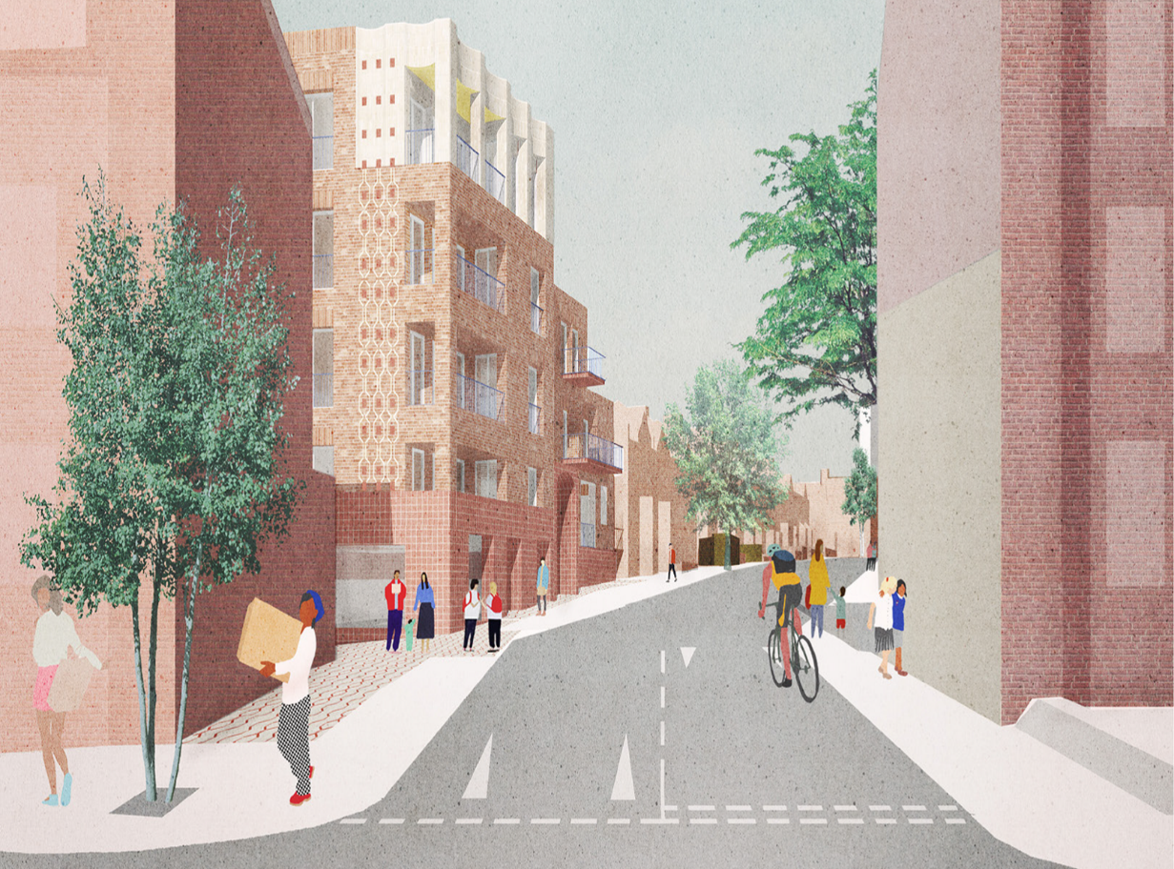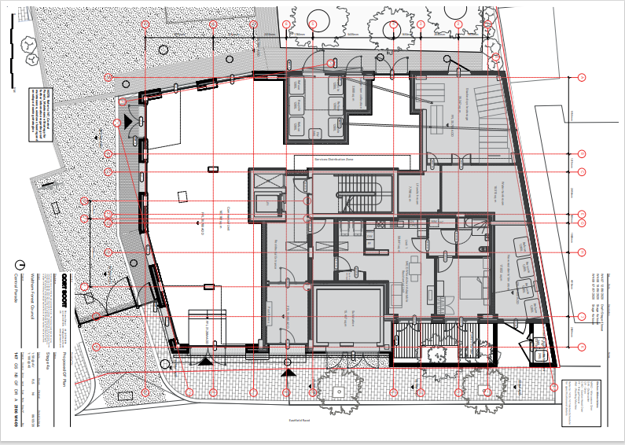

These particulars do not form part of any offer or contract. All statements contained in these particulars are made without responsibility of the vendor/agent/lessor and should not be relied upon as statements or representations of fact. Any intending purchasers/tenants must satisfy themselves by inspection or otherwise as to the correctness of each of the statements contained in these particulars. The vendor/agent/lessor does not give any warranty whatsoever in relation to the property.