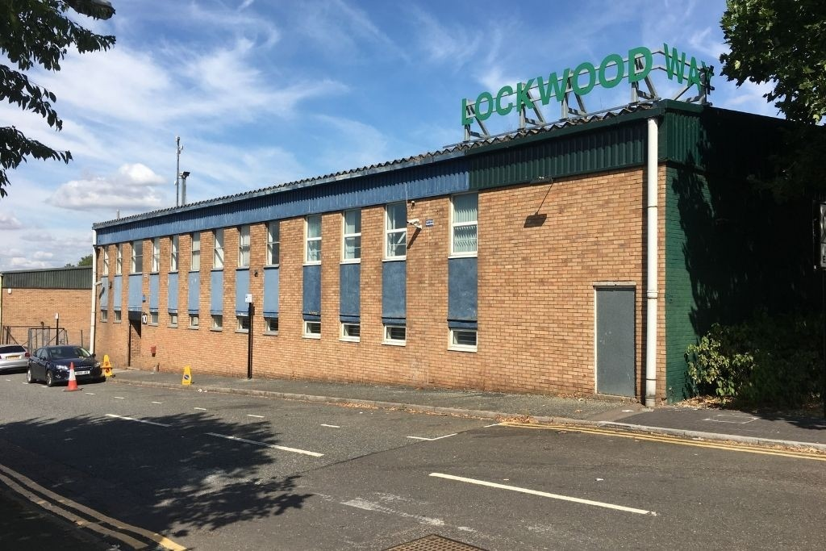
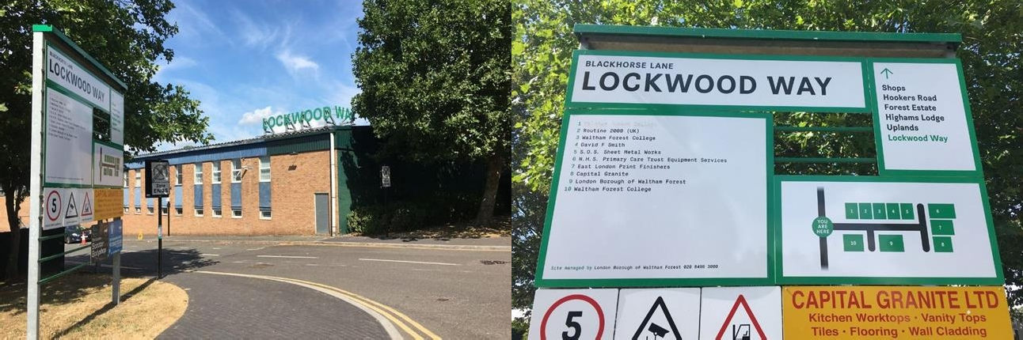

AVAILABLE ‐ TO LET
UNIT 9 LOCKWOOD WAY, WALTHAMSTOW, LONDON E17 5RB

Industrial for Rent, 10,470 Sq Ft Leasehold on Application

UNIT 9 LOCKWOOD WAY, WALTHAMSTOW, LONDON E17 5RB

Industrial for Rent, 10,470 Sq Ft Leasehold on Application
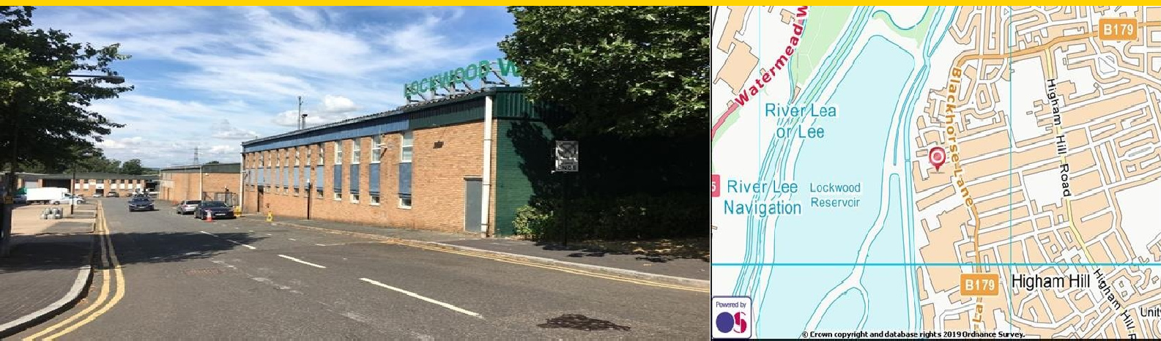

Unit 9 is a single storey industrial/warehouse unit with first floor offices located on the Lockwood Way Industrial Estate.

This estate is approximately 1.5 miles south of the Billet roundabout granting access to the A406 which in turn grants access to the M11 and M25 to the north. The unit is accessed directly from Blackhorse Lane. It also benefits from good rail links being just 0.6 miles to Blackhorse Road Station (Victoria Line) and 1.5 miles to Tottenham Hale Station (Victoria Line/Greater Anglia)

Highlights
Allocated Yard/Parking Offices
24 Hour Access Kitchen Facility Loading Doors Three phase power

Rent Leasehold on Application

Business Rates (Est) £92,500 Rateables value

Building type Industrial

Service Charge (Est) To be confirmed.

VAT Plus VAT if applicable

EPC Rating D - 88

Contact us

London Borough of Waltham Forest
Town Hall Complex,
Forest Road
London,
E17 4JF

propertyenquiries@walthamforest.gov.uk

Area Estate Manager: Gordon Edward
Email: Gordon.edward@walthamforest.gov.uk

These particulars do not constitute an offer or contract. Applicants should satisfy themselves as to the correctness of the details. Value added tax may be payable on rents, prices or premiums. Photographs are for illustration only and may depict items which are not included in the sale of the property.

