Property and Asset Management
Director – Commercial Estate & Investment: Freddie Murray
Magistrates Building, Waltham Forest Town Hall Complex, 1A Farnan Avenue, Walthamstow, E17 4NX

EXPRESSION OF INTEREST FOR SMALL BUSINESS PREMISES:
Ground Floor,
1 Hoe Street, London E17 4QH

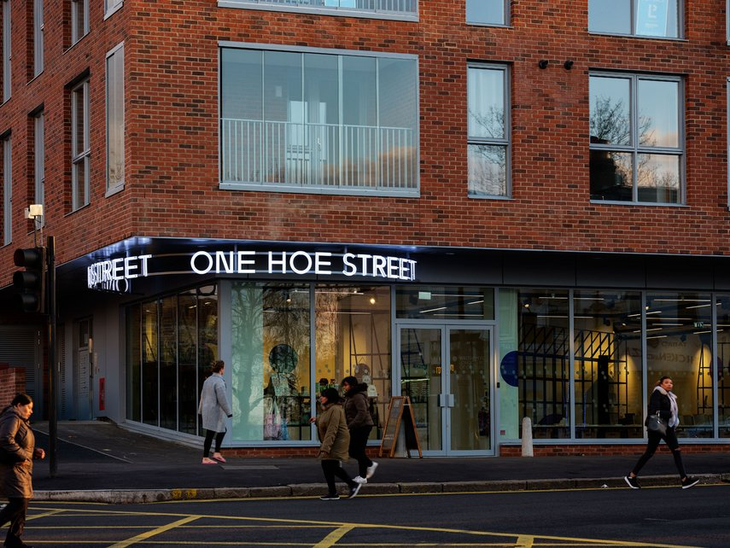

Description:
This newly built mixed-use commercial premises on the Hoe Street has become a gallery of exhibition space for modern and contemporary art run in partnership with the award-winning William Morris Gallery. One Hoe Street was a space that became the hub for the London Borough of Culture in 2019 for art installations, networking sessions, talks, children’s events and more.
One Hoe Street was a key part of the legacy of Waltham Forest’s year as a London Borough of Culture, continuing the Council’s commitment to the arts.
The premise is close to Walthamstow market, Selbourne Walk and numerous independent shops and stalls, alongside the high street brands, means Walthamstow itself is great for shopping and Dine-in. The Victoria Line station at Walthamstow is just a short 10-minute walk away, so has great access to the City and is 15 minutes by road from the A406 North Circular, we near by car parking at The Mall.
The new commercial unit is suitable for numerous uses including B1 (Office use) and D1 community space use and potential change of use with Landlord consent to planning use class E.
The council is seeking expressions of interest from innovative and unique businesses for this new exciting opportunity.
New Term
Rent at £90,000 pa. including service charges.
New FRI lease for a term of 10 years with single upwards only rent reviews after 5 year.

Floor Areas: (see layout plans at Appendix 1)
Arrange on the ground floor
The premises rear is open planned area 2960 sq. ft. (275 sq. m²)
Highlight of the Premises
Flexible lease terms
Desk space per hiring available at £100 per week all inclusive.
Open Plan Accommodation
Self-contained workspace/meeting room

If you are interested in finding out more and are serious in expressing an interest, then please get in touch directly with the Council and we are happy to discuss the potential terms on offer.

Contact details: Without prejudice and subject to contract, to the following address:

Property and Asset Management, London Borough of Waltham Forest | Magistrates Court | Town Hall Complex | 1 Farnan Avenue| London E17 4JF.

Email: tina.ogunremi@walthamforest.gov.uk
Mobile: 07435 998387

Appendix 1

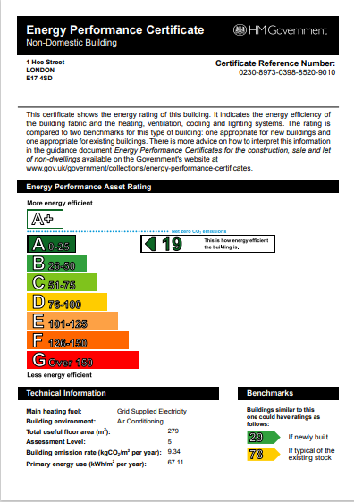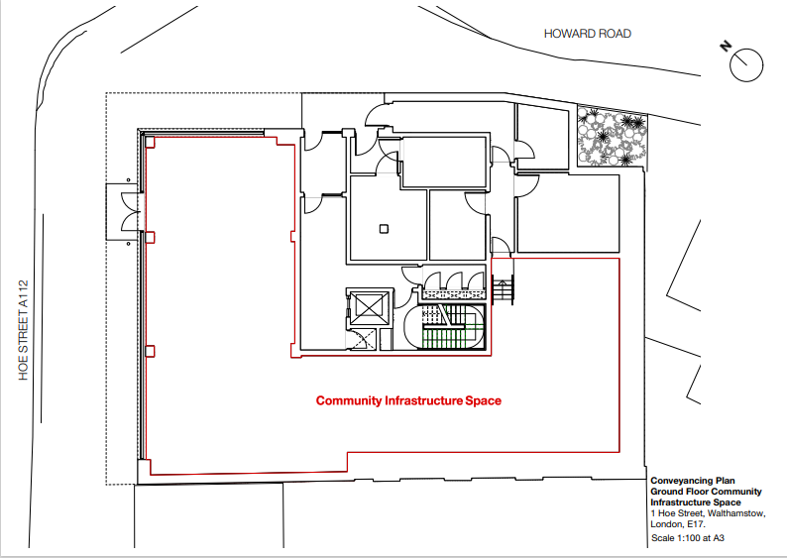

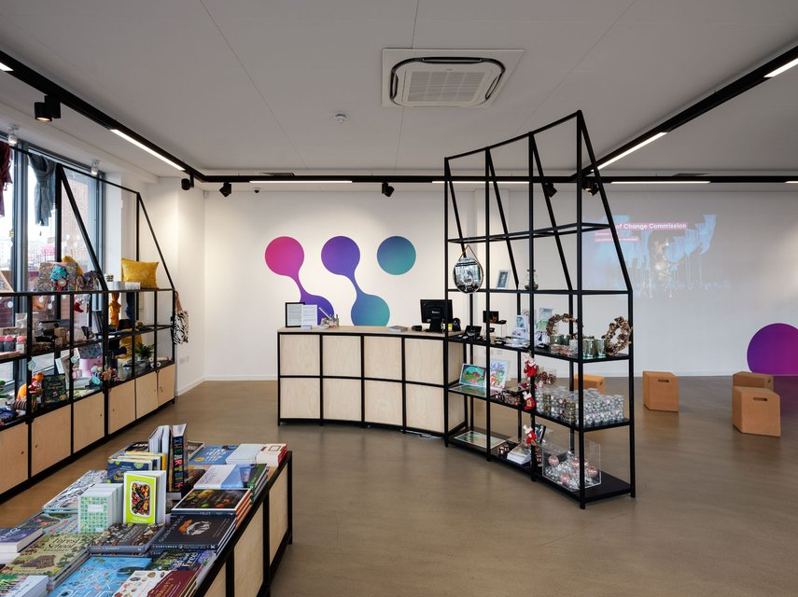

These particulars do not form part of any offer or contract. All statements contained in these particulars are made without responsibility of the vendor/agent/lessor and should not be relied upon as statements or representations of fact. Any intending purchasers/tenants must satisfy themselves by inspection or otherwise as to the correctness of each of the statements contained in these particulars. The vendor/agent/lessor does not give any warranty whatsoever in relation to the property.

