BIKE SHEDS IN FRONT GARDENS
Any outbuilding, including a bike or bin store, within your front garden area will require planning permission. The following note sets out the Waltham Forest Guidance on when planning permission is required and, when you apply for planning permission, what type / form of bike shed is likely to be considered acceptable.
Do I need planning permission for a bike shed/container in a garden?
- In the garden of a flat – YES
- In the front garden of a house (or any side garden adjoining a public road) – YES.
- In the rear garden of an unlisted house not in a conservation area – NO, except that under Permitted Development Rights buildings “incidental to the enjoyment of the dwellinghouse” are restricted to a height of 4m overall and 2.5m at the eaves, or 2.5m overall if within 2 metres of the boundary. Also, no more than half the area of land around the "original house" would be covered by additions or other buildings.
- In the rear garden of a house in a conservation area– as for rear gardens above.

More guidance can be found on the Planning Portal’s interactive house at: https://interactive.planningportal.co.uk/detached-house

What additional permissions may be needed?
- Listed Building Consent may be necessary if your property is listed as being of historic interest; if you feel you need advice, contact our Design and Conservation team. Information on listed buildings is also available from https://historicengland.org.uk/
- Building regulations permission may be needed. Generally a Building Regulations Notification is not required for a shed/container whose floor area is less than 8 sq.m [this covers most garden sheds/ bike containers]. If you feel you need advice, contact our Building Control team.

Am I likely to get planning permission?
When considering a bike shed / container in your front garden please:
- Consider the best position in the garden not only for your ease of access but also to minimise intrusion to both the neighbours’ views and those of the passing public.
- Discuss your ideas with your neighbours and try to meet any criticisms they may have about your choice.

Applying for Planning Permission

Guidelines on what is likely to be acceptable:
- Keep the size of your shed/container within the most common maximum dimensions of 2m wide x 1m deep x 1.5m high.
- A mono-pitched roof often has a lower profile than a ridged roof and this can make the structure less obtrusive.
- Select a colour for the shed/container which is not obtrusive and which fits in with its surroundings. Note that varnish or some coloured wood stains may look too conspicuous, even though a shed is constructed from 'natural' wood.
- Try to screen the shed/container to some degree with planting, a wall, or other discreet means.
- Retain at least 50% front garden area
- Try to site perpendicular to the highway / footway, located along side boundary.
- Consider how the bike shed will relate to any other outbuildings or storage requirements in the front garden.

Good Examples

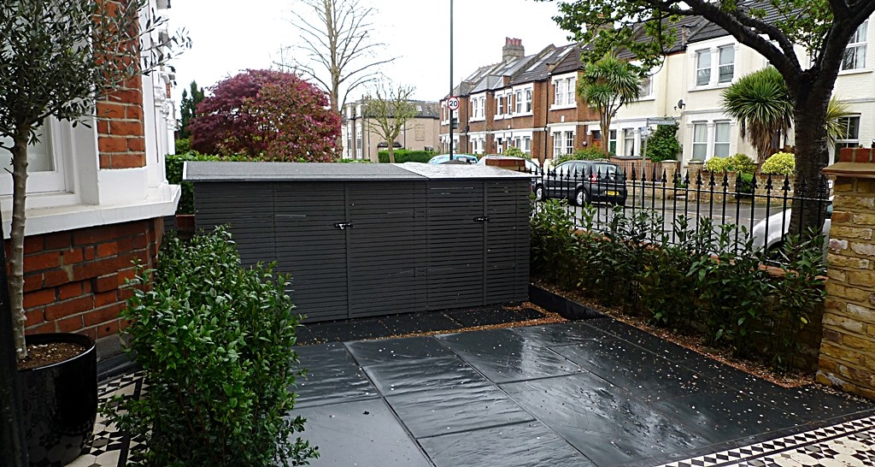
Mono pitched roof, colour and scale matched to surroundings
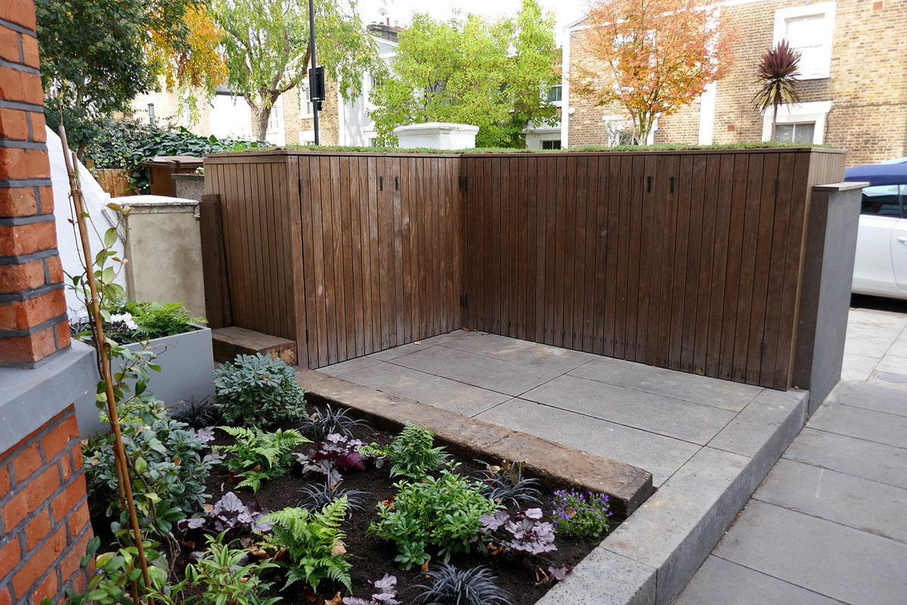
Integrated within the street scene and existing boundary treatment

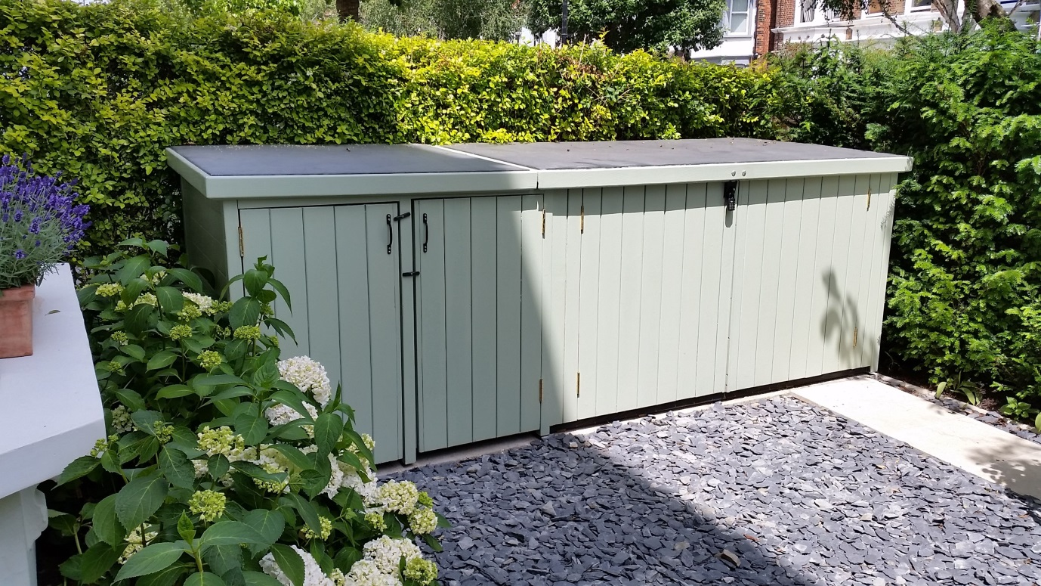
Mono pitched roof, perpendicular to highway, softened with planting

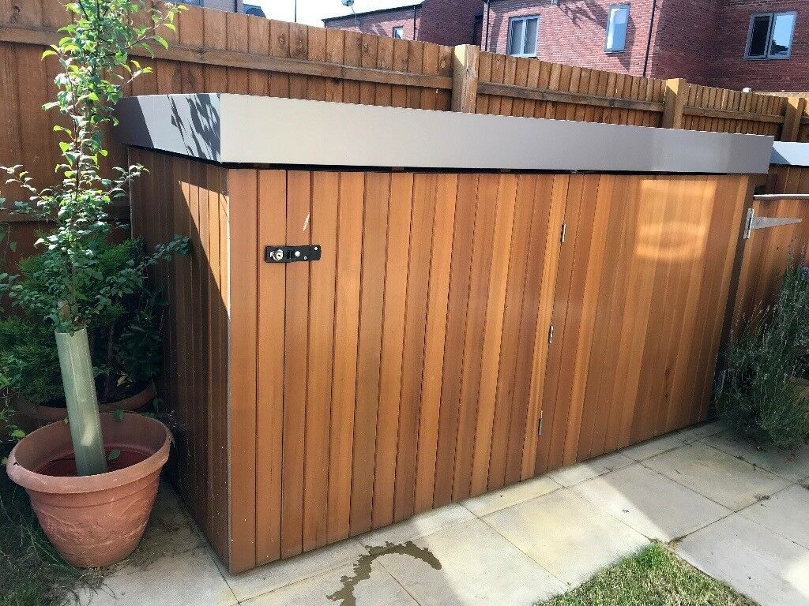
Perpendicular to highway, along the side boundary, materials in keeping with existing boundary treatment

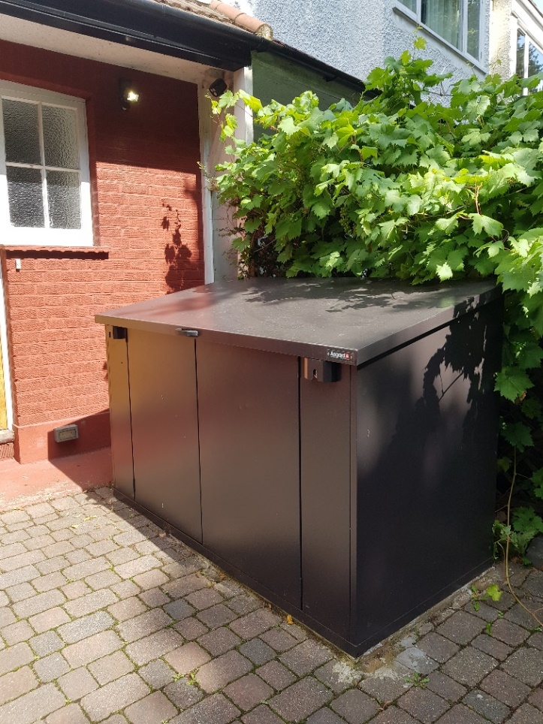
Mono pitched roof, along the side boundary, softened with planting
We would not support:

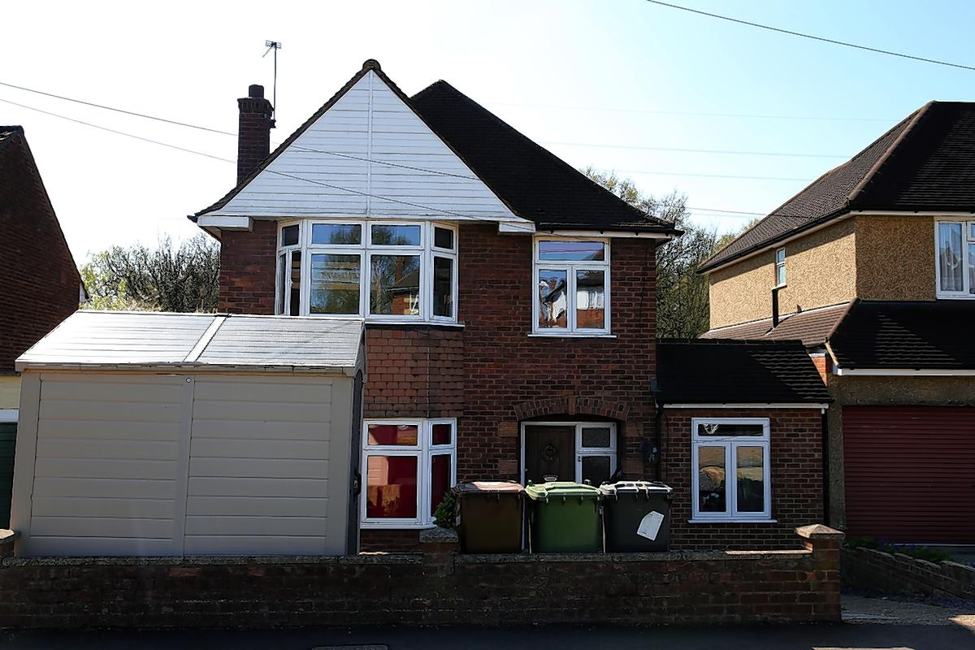
Excessive size, dual pitched, inappropriate materials, inappropriate siting

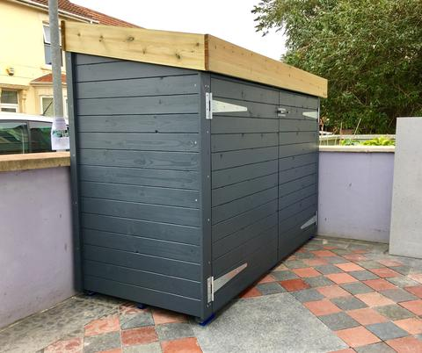
Excessive height, not perpendicular to highway along side boundary

