Room Hire
Guide

Walthamstow, Leytonstone, Leyton,
Lea Bridge, Hale End & Wood Street

Table of
Contents

02 Walthamstow Library
03 Leyton Library
04 Leytonstone Library
05 Lea Bridge Library
06 Hale End Library
07 Wood Street Library
08 Room Hire Charges
09 Terms & Conditions of Hire
11 Customer Feedback Form
12 Booking Form

Walthamstow Library |  |  |  |  |  | 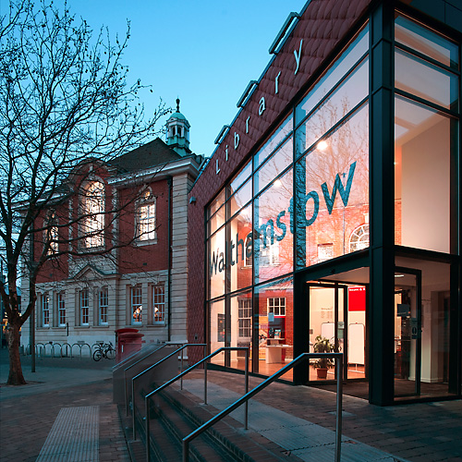
 | High Street, Walthamstow, London, E17 7JN
 | Library.Bookings@walthamforest.gov.uk
 | 020 8496 3000
 | Monday – Friday: 9am – 7pm  Saturday: 9am – 6pm  Sunday: 10am – 4pm
Meeting Room 1 |  |  |  |  |  | 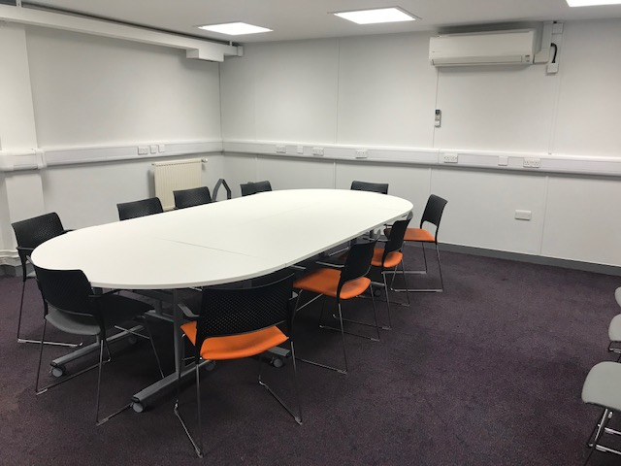
Max Capacity |  |  | 10-35
Location |  |  | First Floor
 |  |  |  | 
Meeting Room 2 |  |  |  |  |  | 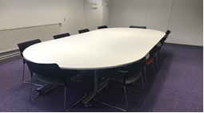
Max Capacity |  |  | 10-20
Location |  |  | First Floor
 |  | 
ICT Suite |  |  |  |  |  | 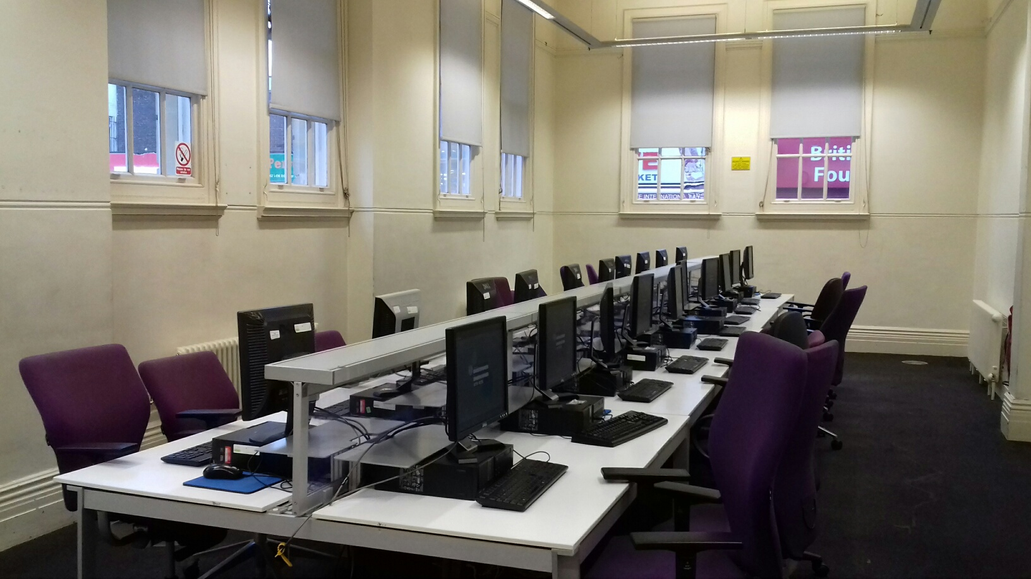
Max Capacity |  |  | 20
Location |  |  | Ground Floor
Community Room |  |  |  |  |  | 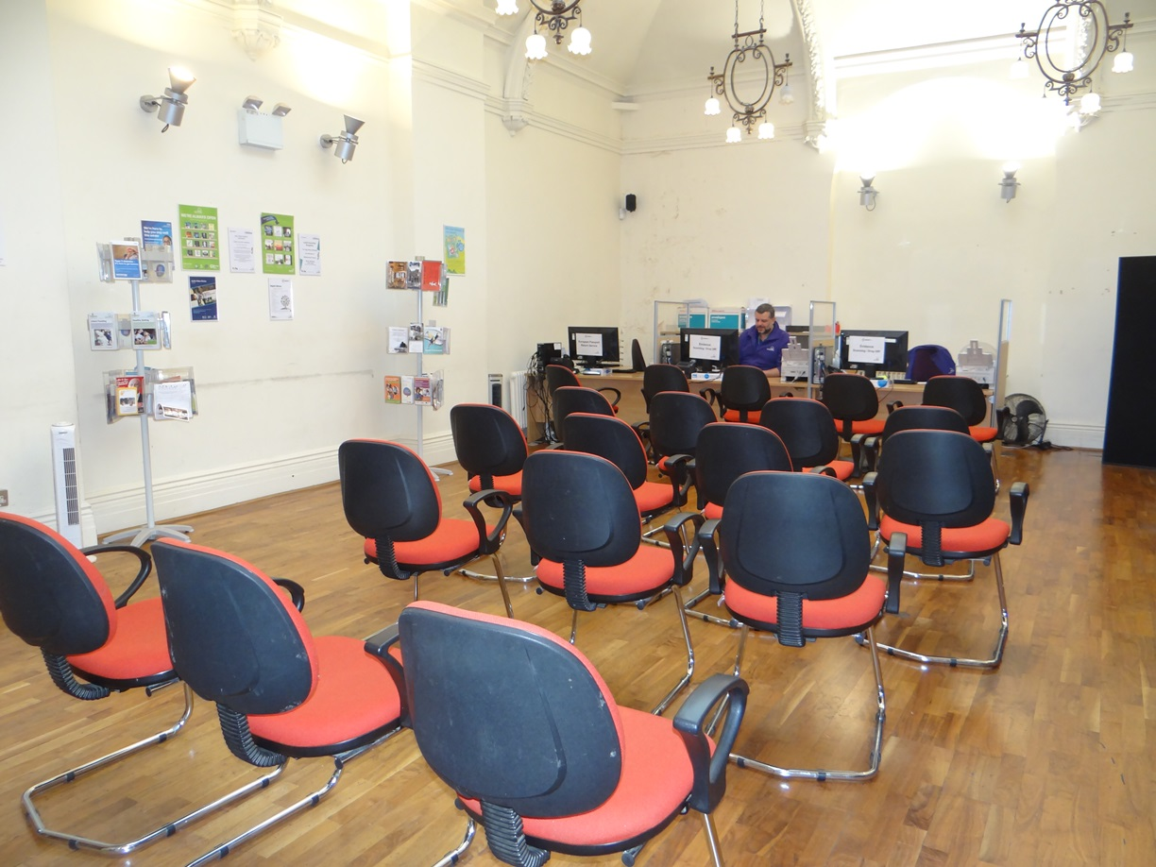
Max Capacity |  |  | 25
Location |  |  | Ground Floor

Leyton Library |  |  |  |  |  | 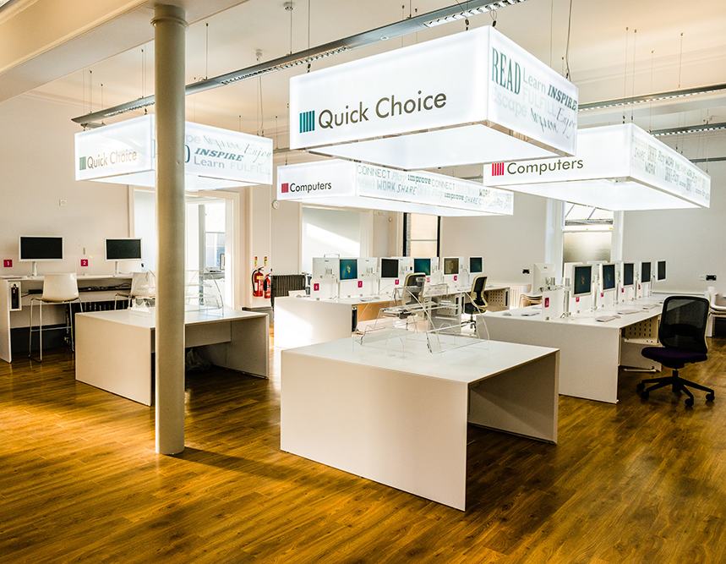
 | High Road, Leyton, London E10 5QH
 | Library.Bookings@walthamforest.gov.uk
 | 020 8496 3000
Monday – Friday: 9am – 7pm
Saturday: 9am – 6pm
Sunday: 12pm – 4pm
Meeting Room |  |  |  |  |  | 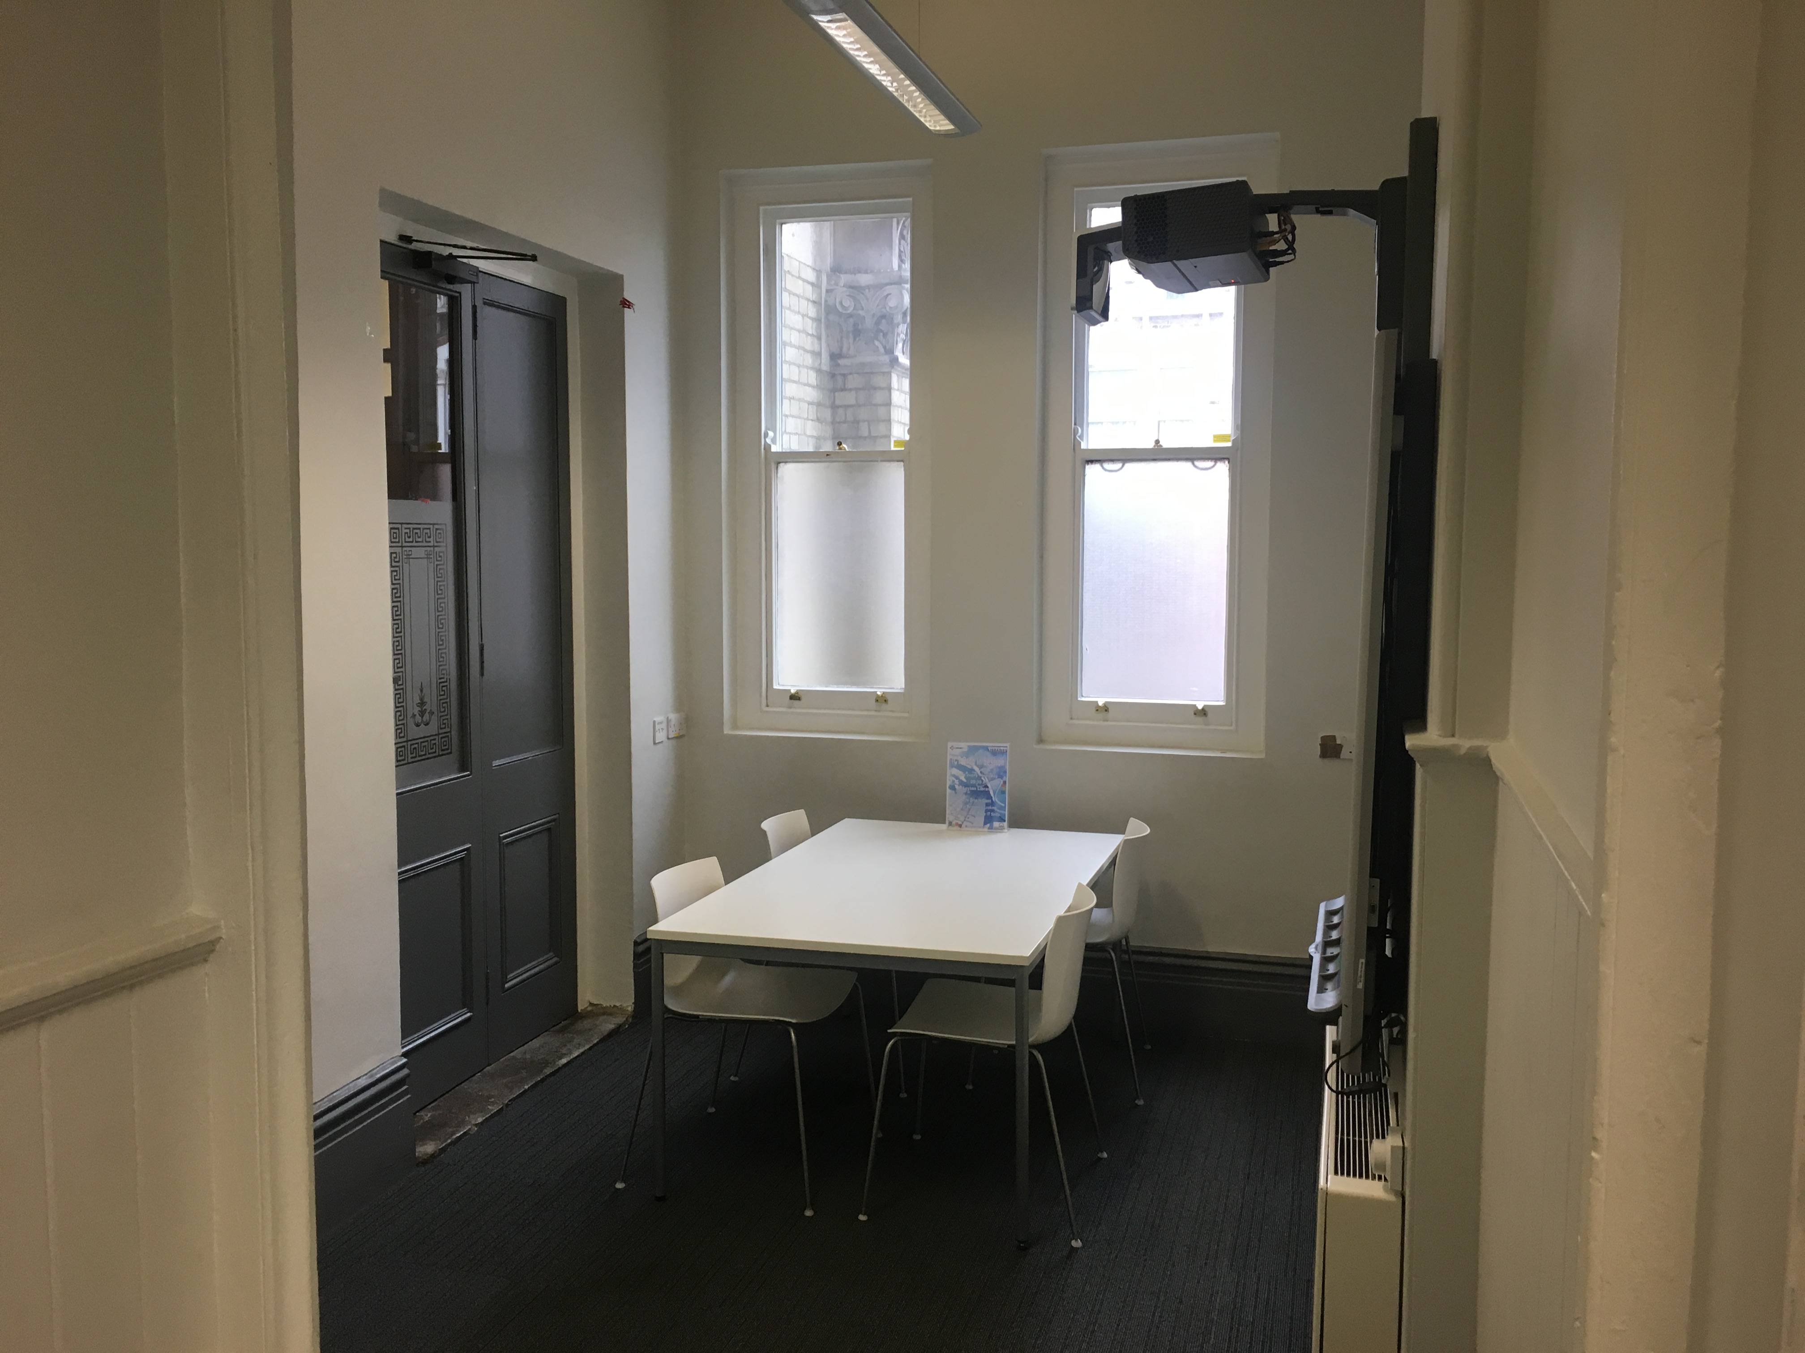
Max Capacity |  |  | 8
Location |  |  | Ground Floor
Community Room (The Lighthouse) |  |  |  |  |  | 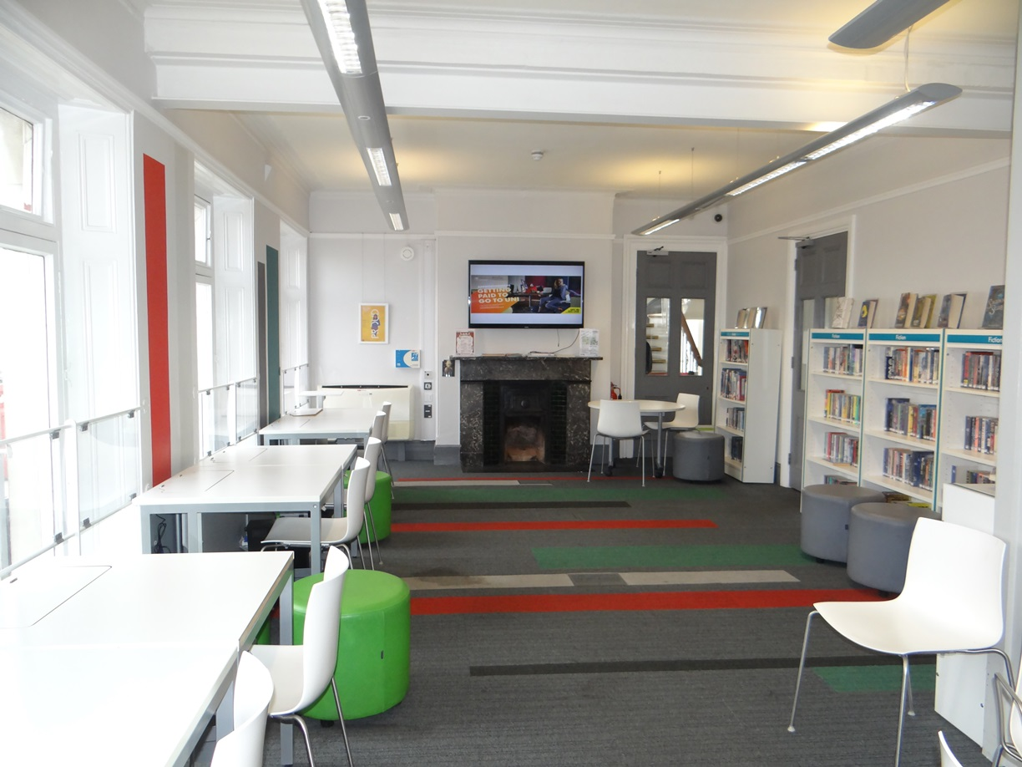
Max Capacity |  |  | 15-20
Location |  |  | First Floor

Leytonstone Library |  |  |  |  |  |  |  |  | 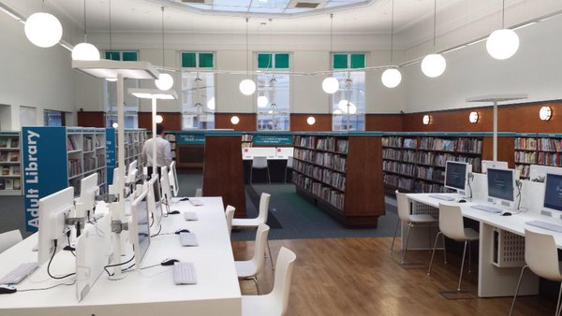
 | Church Lane, Leytonstone, London, E11 1HG
 | Library.Bookings@walthamforest.gov.uk
 | 020 8496 3000
Monday – Friday: 9am – 7pm
Saturday: 9am – 6pm
Sunday: 12pm – 4pm
Meeting Room (The Octagon) |  |  |  |  |  |  |  |  | 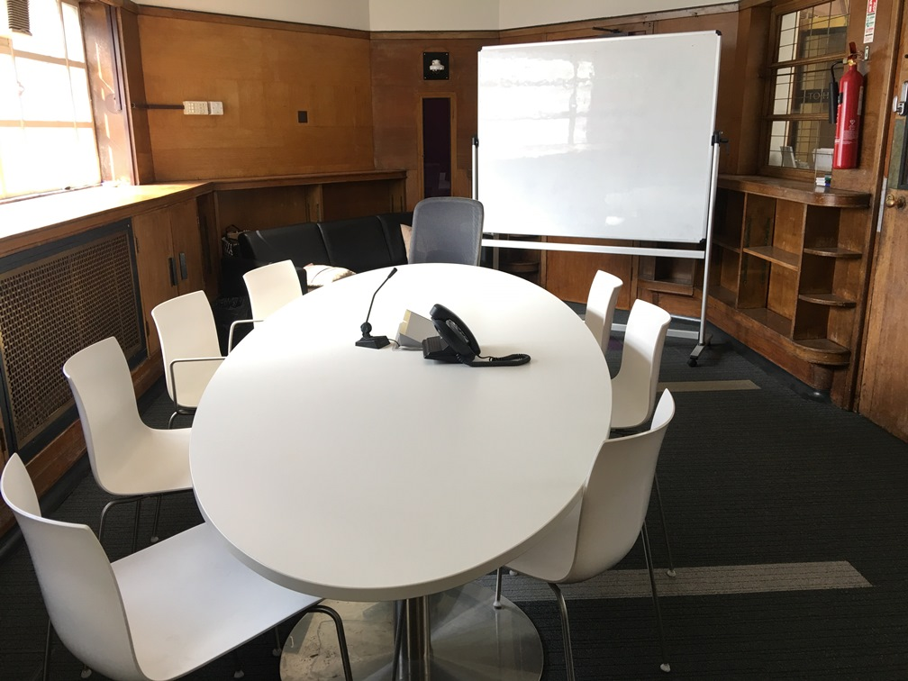
Max Capacity |  |  |  |  | 8
Location |  |  |  |  | First Floor
Meeting Room (The Curve) |  |  |  |  |  |  |  |  | 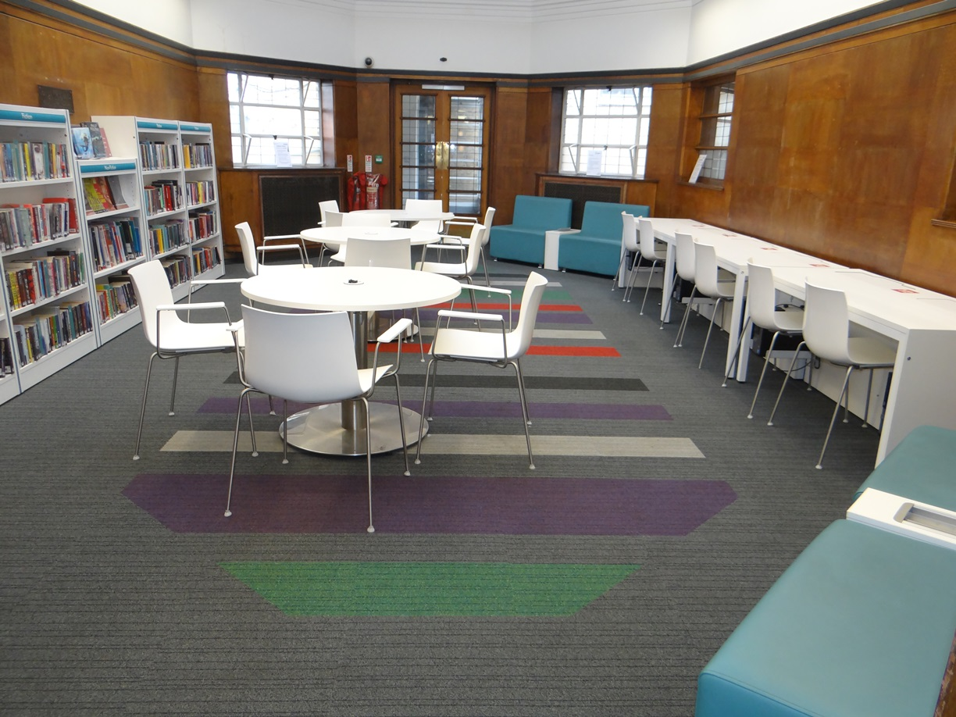
Max Capacity |  |  |  |  |  | 12-26
Location |  |  |  |  |  | First Floor
The Space |  |  |  |  |  |  |  |  | 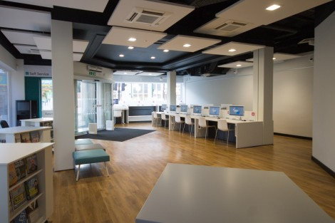
Max Capacity |  |  |  |  |  | 40-60
Location |  |  |  |  |  | Ground Floor
The Hall |  |  |  |  |  |  |  |  | 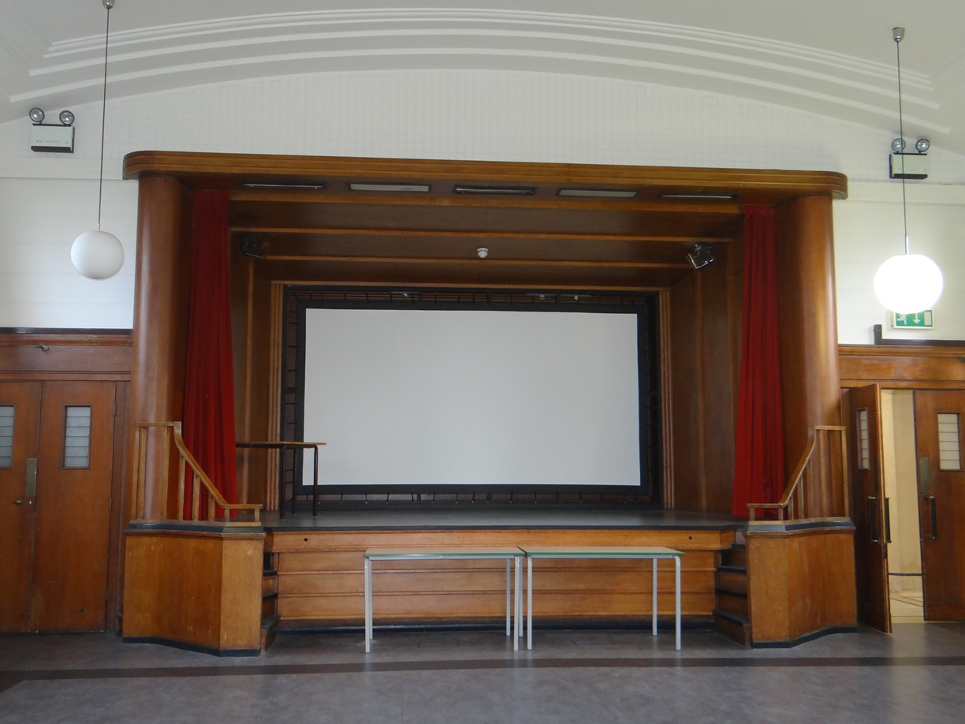
Max Capacity |  |  |  |  |  | 80
Location |  |  |  |  |  | First Floor

Lea Bridge Library |  |  |  |  |  | 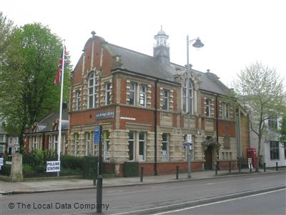
 | Lea Bridge, Leyton, London E10 7HU
 | Library.Bookings@walthamforest.gov.uk
 | 020 8496 3000
Tuesday, Wednesday, Thursday: 10am – 6pm
Saturday: 10am – 4pm

Community Room |  |  |  |  |  | 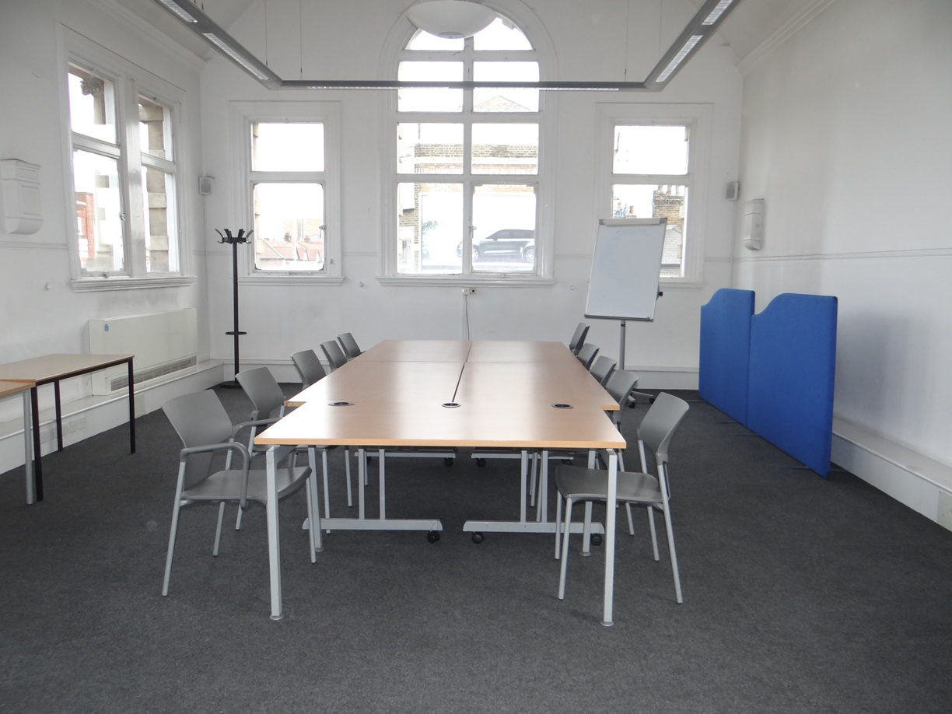
Max Capacity |  |  | 20-50
Location |  |  | First Floor
ICT Suite |  |  |  |  |  | 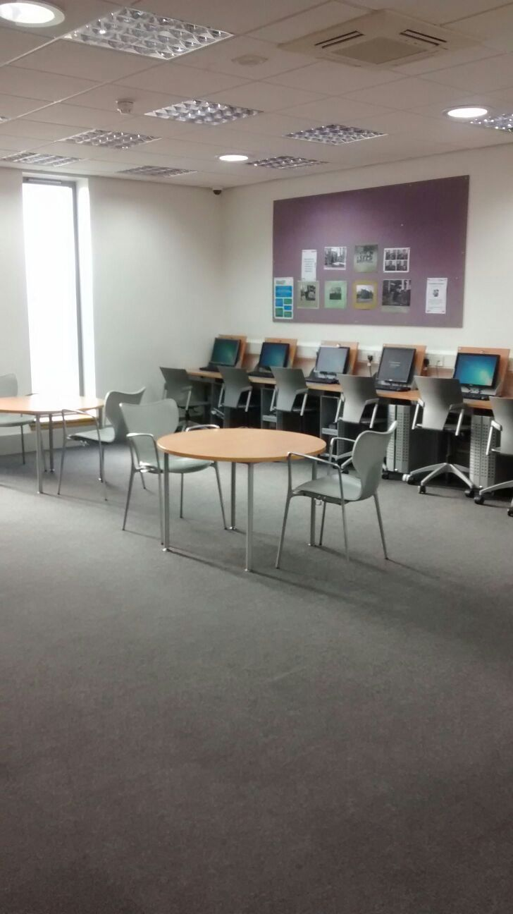
Max Capacity |  |  | 25
Location |  |  | Ground Floor

Hale End Library |  |  |  |  |  | 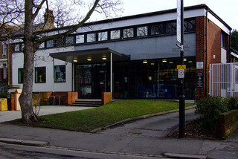
 | Castle Avenue, Higham Park E4 9QD
 | Library.Bookings@walthamforest.gov.uk
 | 020 8496 3000
Tuesday, Wednesday, Friday: 10am – 6pm
Saturday: 10am – 4pm

Community Room 1 |  |  |  |  |  | 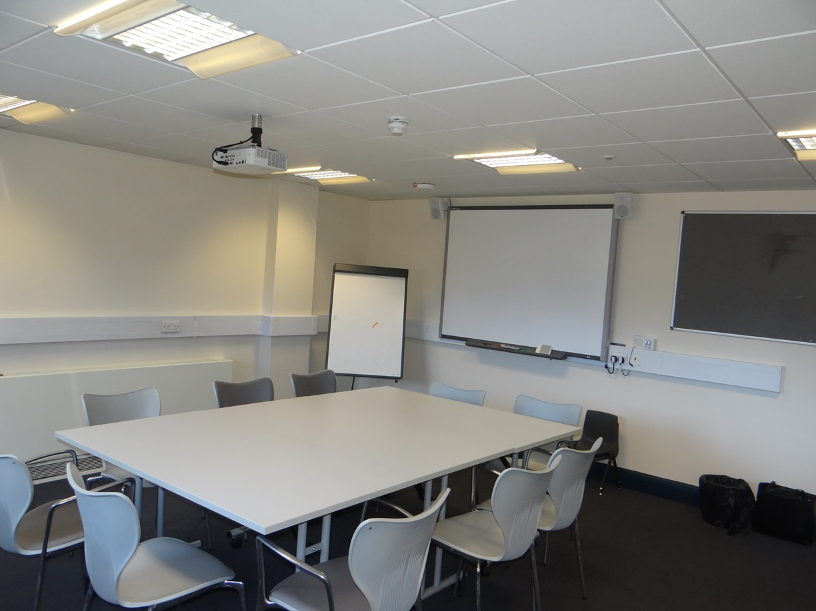
Max Capacity |  |  | 12-20
Location |  |  | First Floor
Community Room 2 |  |  |  |  |  | 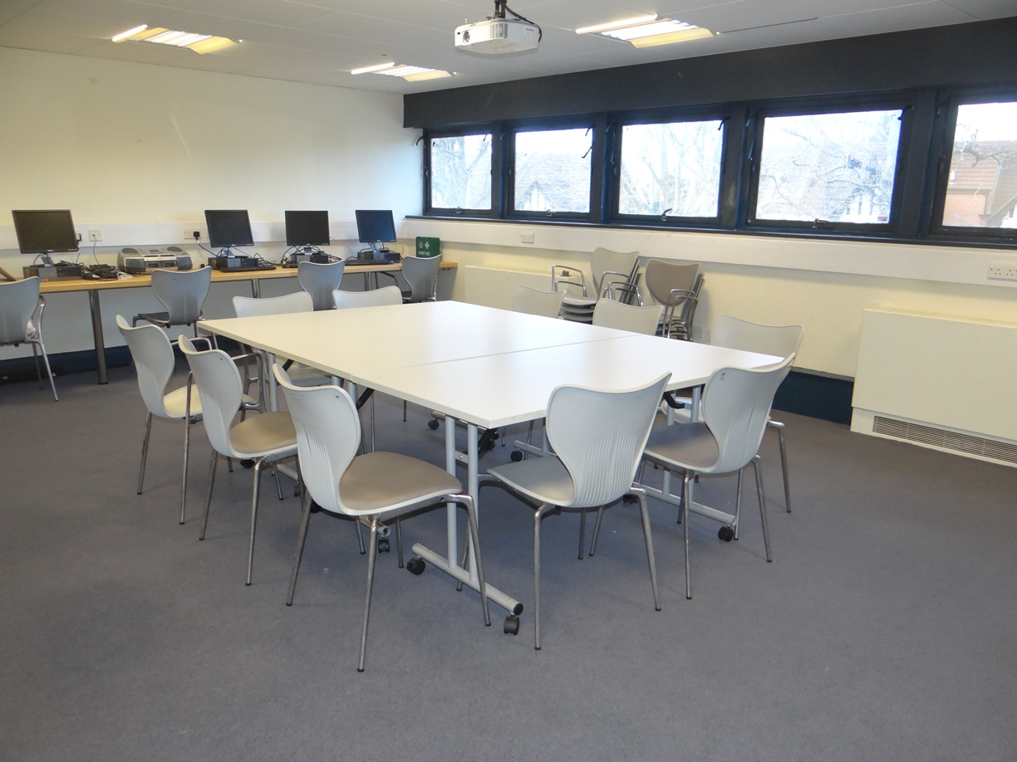
Max Capacity |  |  | 15-30
Location |  |  | First Floor

Wood Street Library |  |  |  |  |  | 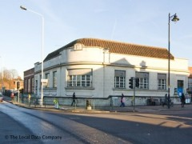
 | Forest Road, Walthamstow E17 4AA
 | Library.Bookings@walthamforest.gov.uk
 | 020 8496 3000
Monday, Tuesday, Friday: 10am – 6pm
Saturday: 10am – 4pm

Community Room |  |  |  |  |  | 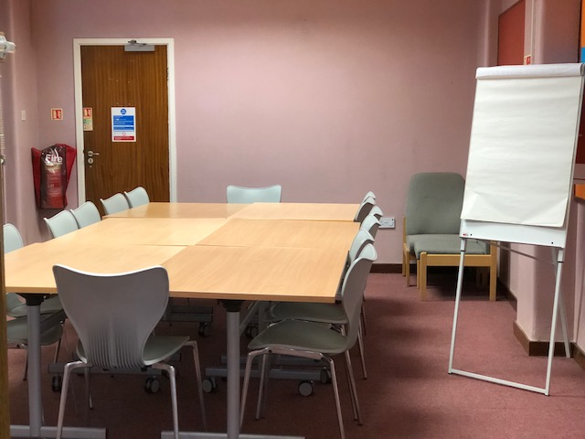
Max Capacity |  |  | 12-25
Location |  |  | Ground Floor

Please note the changes to our fees and charges from 1st April 2018
Room Hire Charges |  |  | Standard Hire Charge (Per Hour) |  | ¹Concessionary Hire Charge (Per Hour) |  | ²Regular Hirers Charge (Per Hour)
Library | Room | Capacity | Opening Hours | Out of Opening Hours | Opening Hours | Out of Opening Hours | Opening Hours | Out of Opening Hours
Walthamstow | Meeting Room 1 (1st Floor) | 10-35 | £27.80 | £56.70 | £13.40 | £45.30 | £11.30 | £26.80
Walthamstow | Meeting Room 2 (1st Floor) | 10-20 | £36.00 | £68.00 | £17.50 | £49.40 | £14.40 | £29.90
Walthamstow | ICT Suite (Ground Floor) | 20 |  | £65.90 |  | £48.40 |  | £29.90
Walthamstow | Community Room  (Ground Floor) | 25 |  | £68.00 |  | £49.40 |  | £29.90
Leyton | Meeting Room (Ground Floor) | 8 | £24.70 | £56.70 | £12.40 | £44.30 | £9.80 | £25.80
Leyton | Community Room  (The Lighthouse) | 15-20 | £27.80 | £68.00 | £13.40 | £49.40 | £11.30 | £29.90
Leytonstone | Meeting Room (The Octagon) | 8 | £24.70 | £56.70 | £12.40 | £44.30 | £9.80 | £25.80
Leytonstone | Meeting Room (The Curve) | 12-26 | £27.80 | £56.70 | £13.40 | £44.30 | £11.30 | £26.80
Leytonstone | Ground Floor (The Space) | 40-60 |  | £76.20 |  | £54.60 |  | £34.00
Leytonstone | The Hall (1st Floor) | 80 | £62.80 | £94.80 | £31.90 | £63.90 | £25.80 | £41.20
Lea Bridge | Community Room (1st Floor) | 20-50 | £36.00 | £68.00 | £17.50 | £49.40 | £14.40 | £29.90
Lea Bridge | ICT Suite (Ground Floor) | 25 |  | £65.90 |  | £48.40 |  | £29.90
Hale End | Community Room1(1st Floor) | 12-20 | £27.80 | £56.70 | £13.40 | £45.30 | £11.30 | £26.80
Hale End | Community Room2(1st Floor) | 15-30 | £36.00 | £68.00 | £17.50 | £49.40 | £14.40 | £29.90
Wood Street | Community Room  (Ground Floor) | 15-20 | £36.00 | £68.00 | £17.50 | £49.40 | £14.40 | £29.90
Use of Laptop, Projector or Screen |  |  | £12.40 | Use of ICT Equipment |  | £7.20
¹Charity/Non-Profitable Organisation-²Advance Booking for 12 weeks and payment made

Terms and Conditions of Hire

1. Application – All applications for hire must be made on this form and returned to the Library Manager. Where the hirer is not an individual, the person who signs the form should be duly authorised to act for the hirer and must be over 18 years of age.
2. Confirmation - A booking is confirmed when a signed Booking Form has been received by the Library, and written confirmation has been received from the Library concerned.
3. Venue/Advertising - All correspondence and publicity materials should be addressed and referred to the Library. Fly posting of publicity material relating to the event is not permitted; posters advertising the event should be displayed at approved advertising stations. In the event of a breach of this condition the Borough reserves the right to cancel the booking advertised on the posters. Under the provisions of the Highways Act 1980 and the Planning Regulations it is forbidden to advertise and put up signs on the highway for functions held at the Library Hall concerned.
4. Charges/Payment
a) Charges for the use of facilities shall be as laid down by the Borough.
b) A booking fee will be required with confirmation of hiring. The fee will be 10% of the hire charge.
c) On confirmation of the booking the Hirer shall arrange payment for the full amount to be received within 7 days of booking confirmation. Bookings cannot proceed without full payment.
d) An additional fee is payable by the Hirer for each hour or part thereof that the booked facility over runs the contractual period. This fee will be at least twice the hourly booking fee plus a charge for any labour and/or overtime costs involved.
e) Where any areas have to be specially prepared, the setting up and breaking down of equipment must be carried out within the hired times and is the responsibility of the Hirer, unless otherwise confirmed in writing by Library Manager.
5. Cancellations – Only acceptable in writing, a) By Hirer and b) By Borough
a) Once a booking has been confirmed, the Hirer shall pay to the Borough the full amount plus any direct or indirect costs occasioned by the cancellation however provided not less than 10 days’ notice is given in writing and LBWF are able to re-let your booking a 10% admin charge will be payable.
b) The Borough reserves the right to close or prohibit the use of any facilities at its discretion. All monies paid in respect of a booking cancelled in accordance with this condition will be refunded but the Borough will not be liable for any other expenditure incurred or loss sustained directly or indirectly by the Hirer arising from such cancellation.
6. Vacating the premises - Hirers are requested to ensure that the booked facility is vacated by the time shown on the Booking Form. Any event, which proceeds beyond this contractual period, is liable to excess charge (see Charges).
7. Smoking - The Library has a No Smoking policy.
8. Admission - The Borough reserves the right at its absolute discretion to refuse admission of, or to evict any person from the Library.
9. Indemnity - The use of the ROOM/HALL or any part thereof is entirely at the risk of the Hirer and the Borough accepts no responsibility for any claims, actions, demands, proceedings or costs arising out of any claims made against the Hirer by a third party and the Hirer shall indemnify the Borough against any such claims, actions, demands, proceedings or costs which may be brought against the Borough arising out of or incidental to the hire of facilities and equipment and shall be adequately insured.
10. Alterations - The Hirer shall not carry out any alterations to the buildings, nor shall fix or make fixings for any apparatus, equipment or decorations without prior written permission from the Library management.
11. Damage - The Hirer agrees to pay LBWF on demand the cost of repairing or making good any loss or damage (fair wear and tear excepted) arising out of or incidental to the hiring. An appointed officer of the Borough shall certify the cost of such damage.
12. Loss of and Damage to Property - The Borough will under no circumstances accept responsibility or liability for any damage to or loss of property or articles placed or left within the ROOM/HALL, or any part thereof, by the Hirer, unless such loss or damage arises directly as a result of negligence by the Borough.

13. Supervision - The Hirer is to be responsible for:
a) Administration, organisation, control and running of the event. No event may start until the Hirer or a responsible person(s) within the organisation is in attendance.
b) Ensuring all instructors/supervisors in any LBWF endorsed activity open to vulnerable/young people are suitably qualified and have been successfully DBS checked. The organization must be affiliated to a recognized governing body, comply with the Borough’s Child Protection Policy and have public liability insurance to an agreed value with the Library Manager (see Indemnity above).
c) Supervision and control of all visitors, spectators and officials especially children under 16 years old
d) Leaving all premises, changing rooms, toilets, to the satisfaction of the Library management.
e) Stewards. Persons hiring facilities for private functions for entertainment purposes e.g. parties, weddings, dances etc. must inform the Library of the full names of stewards responsible for that event and having sufficiently qualified stewards to LBWF Safe Door Standard.
14. Transfer of Booking - The right to use the facilities or equipment is not transferable.
15. Subletting - No hirer may sublet or make available any area or part thereof to a third party without prior written consent of the Borough.
16. Capacity – The maximum number of people admitted to any function shall be based on booked facility but must be at the absolute discretion of the Borough and based on the number specified on the booking confirmation from the Library.
17. Gambling - No games of chance, sweepstakes, or any betting is allowed in the ROOM/HALL without prior written consent.
18. Photographs - No photographic equipment may be brought into the ROOM/HALL for commercial purposes without written permission. Photography at exclusive use parties is at the discretion of the hirer. Non-exclusive use parties will be treated as general use sessions where prior permission needs to be obtained.
19. Catering/Own Food & Drink - All catering will be provided by the Hirer.
20. Equipment and Staff - All arrangements regarding equipment, ROOM/HALL layout and help from caretaker must be confirmed with Library management.
21. Sale of Alcohol/Commodities - No hirer may sell or allow to be sold any goods, except with the prior written approval of the Library Manager. To sell Alcohol, permission must be taken from licensing. https://www.walthamforest.gov.uk/content/apply-premises-licence-sell-alcohol
22. Animals - No animals shall be brought into the Library with the exception of dogs assisting the disabled or by prior written consent of the Library Manager.
All handlers shall comply with any instructions from the Library management.
23. Fire Precautions and Other Emergencies - The Hirer shall carry out and observe any instructions issued by the Library management.
24. Compliance with Bye Laws, Regulations, Rules and Licenses
a) All persons, clubs and organisations hiring the facilities provided by the Borough shall comply with all directions given by the authorised officer in charge of
the facility and, at all times, shall observe compliance with the byelaws and regulations.
b) Hirers must obey the Library rules and regulations displayed.
c) Hirers must comply with all Environmental Health, Public Entertainment, Data Protection, Human Rights, Trading and any other relevant legislation in force.
25. Fee/Reward - The Hirer or persons on their behalf shall have committed a criminal offence by offering a fee or reward to Borough employees.
26. Day hire- If the ROOM/HALL is being hired during the day, there should be minimum disruption to the library users. Library is a quiet place and all the rules/regulations must be followed.

Customer Feedback Form
We should be grateful if you would provide feedback on the hire of the facilities for your event in order to help us plan for future events. Thank you.
Organisation:
Date (s):
 | Strongly Agree | Agree | Disagree | Strongly Disagree
1. The facility met the requirements for the event. |  |  |  | 
2. The hiring arrangements were well organised. |  |  |  | 
3. Arrangements on the day were well organised. |  |  |  | 
4. The facility provided good value for money. |  |  |  | 
 | Excellent | Good | Poor | Very Poor
5. Overall please rate the service you received. |  |  |  | 
 |  |  | Yes | No
6. Would you be interested in using our venues for future events? |  |  |  | 
7. How did you hear about the facilities at Waltham Forest Libraries?
8. Please let us know if there is anything we could do to improve the service we offer.

Library Room Hire Booking Form
Your details
Name |  | Organisation:
Address: |  | Phone:
Email:
Booking details
Library Requested:
Room requested: | □ Single Booking □ Block Booking (12 weeks +)
Date(s) of event:
Event name:
Event type/description: | e.g. meeting, workshop, performance
Arrival / Start time: | Please ensure that you include all relevant set-up and pack down time in your booking
Departure / End time: | Please ensure that you include all relevant set-up and pack down time in your booking
Number of attendees:
Requirements: | Please detail required number of tables and chairs, room layout and any equipment needs (may incur additional charges as overleaf)
Additional information | e.g. additional needs of group, equipment you will be providing
Confirmation:
By returning this booking form you are confirming that you have read and agree to the library room hire terms and conditions [attached to this booking form OR set out on the back of this booking form].
Date

Please note: bookings are only provisional until payment has been received. You will receive an email to confirm your booking once your payment has been received.

