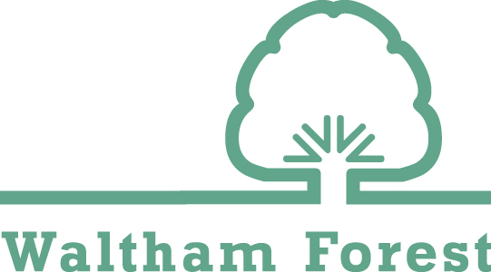
All About Me
Starting School Together

Name:
DOB:

Say Hello to me…
Insert picture

An introduction to me and what is important to me…
My first language, my personality, my favourite things, likes and dislikes, current interests, hobbies/outside the setting activities, allergies/medical information

Who is important to me and my home life…
Parents, carers, siblings, grandparents, aunts and uncles and family friends that are regularly involved in the day to day care. If the child attends another setting or a childminder include the details. Where I live and information about my family including any support they are receiving.

What you need to know to support me to learn and develop…
How I like to learn (refer to the characteristic of effective learning from development matters), types of reactions to certain situations (e.g. shy, excited, confident, confused, angry, happy)

Name of nursery setting
Name of Key Person
Date started at setting |  |  | Number of weekly hours attended
Eligible for EYPP |  | Yes/No | Is the child looked after |  |  | Yes/No
Does the child have a support plan? |  | Yes/No (if answering yes, ensure plan is sent with this document for further details)
Is the child in receipt of SENIF? |  | Yes/No (if answering yes, ensure plan is sent with this document for further details)
Does the child have an EHCP? |  | Yes/No (if answering yes, ensure plan is sent with this document for further details)
Please sign below to indicate this information can be shared with your child’s allocated school
Parent/Carer Signature |  |  |  | Date
Parent/Carer Name

